Business Plan:
Redevelopment of Bexhill site to create a sustainable social enterprise retail and workspace hub

Contents

1: Executive Summary 3
2: Organisation Summary 4-12
3: Project Background 13-19
4: Strategic Context 20-41
5: Project Delivery 42-47
6: Project Resources 48-53
7: Project Costs 54
8: Joint Funding 55
9: Financial Appraisal 56-59
10: Marketing & Communication 60-61
11: Monitoring & Evaluation 62-68
12: Risk Analysis 69
13: Conclusion 70
14: Supporting Information Contents 71

1: Executive summary

The project redevelops an unsightly and dilapidated former garage and petrol station into a retail and workspace hub creating and safeguarding 179 jobs for residents in some of the most disadvantaged neighbourhoods in the country.
Important Features
- HFS is an established local social enterprise and charity with a 30-year track record of successfully delivering services and projects in Hastings and Rother.
- HFS services and projects meet local needs and are consistent with its aims and objectives
  - HFS household furniture stores respond to the need for affordable furnishings in an area with high levels of deprivation.
  - The training projects respond to low skills and confidence among vulnerable adults.
  - The office furniture store responds to the need for affordable equipment for local small businesses.
  - The workspace project has been developed in response to the need for local jobs and opportunities.
- HFS owns its sites in Hastings and Bexhill and is in an excellent position to develop. The Hastings site was successfully redeveloped by HFS in 2007 and the organisation has rigorously planned the redevelopment of the Bexhill site
- The large central Bexhill site has potential to provide not only a larger HFS store to make a wider range of goods available to households and businesses, but also a hub of workspaces for start-ups and small businesses, totalling 1,500m2. Redevelopment of this site will also improve the appearance of London Road, the gateway to the town centre
- There is evidenced need for affordable, modern, flexible workspace for SMEs, start-ups and creatives in central Bexhill which is accessible by public transport and within walking distance of local shops and residential areas
- The workspace hub will create a supportive environment for growing businesses. The building is designed to encourage networking and mutual support, and HFS will employ a co-ordinator to facilitate peer support, signpost to specialist services and promote hub events.
- The development will help organisations to create and safeguard up to 179 total employment outcomes in the first 18 months, and have ongoing job creation impact
- The development contributes to key local strategies and priorities and is supported by a range of key stakeholders, including De La Warr Pavilion, Chamber of Commerce, Bexhill Coastal Communities Team and local authorities
- Project Delivery will be undertaken by a skilled and experienced team. Construction work will be complete by the end of 2020. The impact of the project is long-term because it creates infrastructure for the growing creative and digital sector that will continue to create opportunities long after the funding period.
- A valuable “anchor tenant” is already in place. Rother Voluntary Action (RVA) has a 10-year lease for their base at the HFS site.
- The new buildings will be self-sustaining once established, creating additional jobs and training opportunities every year
- The 2.5m investment will be asset locked. As a registered charity HFS has an asset lock that ensures any property owned must remain for public benefit in perpetuity and cannot be sold off for private gain

2: Organisation summary

Aims, Objectives and legal status
HFS is a charity and social enterprise principally serving the Hastings and Rother areas of East Sussex.
HFS was established in 1988, by, and for, unemployed people and as a response to the very difficult economic situation at the time. Since then it has grown and become more organised in its approach while retaining a passionate commitment to helping vulnerable and disadvantaged people.
The aims of the organisation are:
- alleviating poverty by offering quality, re-usable furniture and household goods to people on low incomes
- reducing waste by re-using quality domestic and office furniture to people and organisations who need them
- creating opportunities, training and jobs for long term unemployed people who are unable to compete in the job market.
- encouraging and supporting other organisations to create opportunities for training and jobs
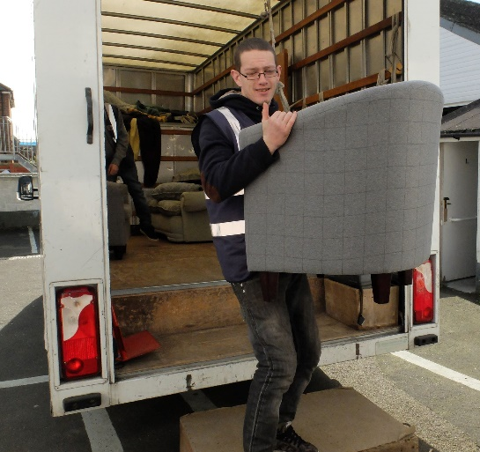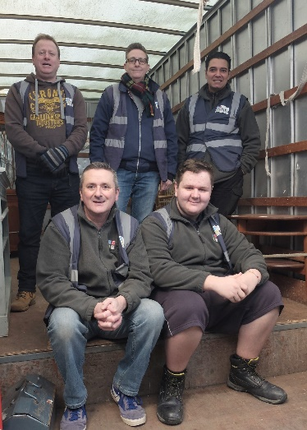

Services, Activities and Beneficiaries
Hastings is the 13th most deprived area in the country (IMD 2015) and Rother has pockets of persistent deprivation, principally in Bexhill and Rye but also in some isolated rural areas. Unemployment in Hastings is 4.5% against the SE average of 1.4% (NOMIS September 2018). Earnings are low in both Hastings (£490 per week) and Rother (£485) against the national (£571) and SE average (£614). Job density in Hastings is 0.65 and 0.73 in Rother (SE: 0.88).
HFS services have been designed against this backdrop, to help people living with low incomes in deprived neighbourhoods to access services and opportunities to improve their quality of life, whether that’s by furnishing their home without going into debt or by moving into employment.

Retail stores
We have two large retail stores – one in Hastings and one in Bexhill - selling unwanted but reusable furniture and appliances, thus preventing them from going to waste in landfill. HFS also stocks paint for decorating and other household items. Each year HFS saves about 300 tons of furniture, electricals and paint, reselling them at a significant discount to people in receipt of welfare and in-work benefits. Not only can families on very low incomes benefit directly, but we also prevent landfill sites from filling up with items that can be recycled and re-used.
HFS delivers affordable goods, free of charge, to approximately 4,000 low-income households each year.
The stores are open to everyone, although items in short supply such as beds and electrical goods are only available to low-income households. Pensioners and students also receive discounts and free local deliveries. Members of the public who are not on a low income and therefore pay the full price for their furniture represent a small minority of HFS customers at present. HFS provides free collections for high quality reusable furniture to maintain its services and robust marketing aims to make HFS the first choice of households disposing of quality used furniture and appliances.
There is an office furniture department at the Bexhill store. Start-ups, micro businesses, charities and other social enterprises are able to buy quality reusable office furniture and equipment, thus enabling more funds to be devoted to the running of the business. Established businesses also find quality used office furniture useful.

Training
Poverty created the demand for HFS and continues to drive the need for our services. We were not satisfied with providing low cost, re-usable furniture and wanted to give our customers hope as well as practical support. Consequently, we have developed our training and volunteer facility so that people can be helped to fulfil their potential and participate fully in the labour market.
Because of historically low levels of educational attainment and the limited work opportunities, aspirations and employability skills have remained sparse. Over the years, HFS has developed high quality training and support packages.
HFS has developed considerable expertise in the support of vulnerable long-term unemployed people, training and supporting them into work. Over 40 people each year are involved with the charity as volunteers, supported to gain skills, confidence and experience. 20% of these gained paid employment last year despite all volunteers being unable to compete in the job market when they first come to HFS.
HFS delivers practical DIY and craft skills outreach sessions at Women’s Refuges across East Sussex, and other community venues through its innovative Workshop On Wheels (WoW) project.
We offer training courses in furniture restoration, carpentry, craft skills and paint effects. These are provided free of charge for people with low incomes, in partnership with other community learning providers, under contract to the local FE College. This enables people to restore and repair older or broken pieces of furniture, thus reinforcing our re-use ethos as well as up-skilling learners.
We have also delivered paid “work-with-training” programmes including in-house apprenticeships, and a programme called L-earn that employs young workless and unqualified NEETs part-time in a pre-apprenticeship scheme. These had a very high success rate; 75% participants moved into employment or education.
The skilled workshop tutors and support worker at HFS received an “Exemplary” rating at their last inspection by the national awarding body, NCFE.
One of the outcomes of the development will be to increase the number of placements that can be provided at HFS to increase the skills, confidence and experience of local unemployed people.

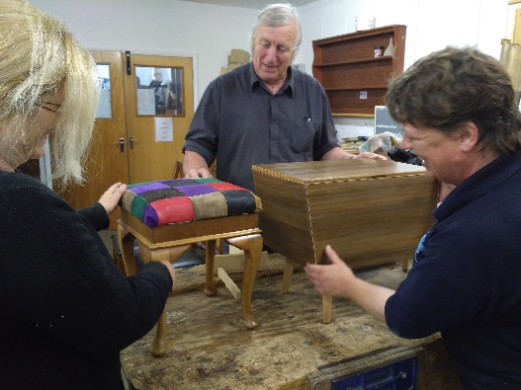
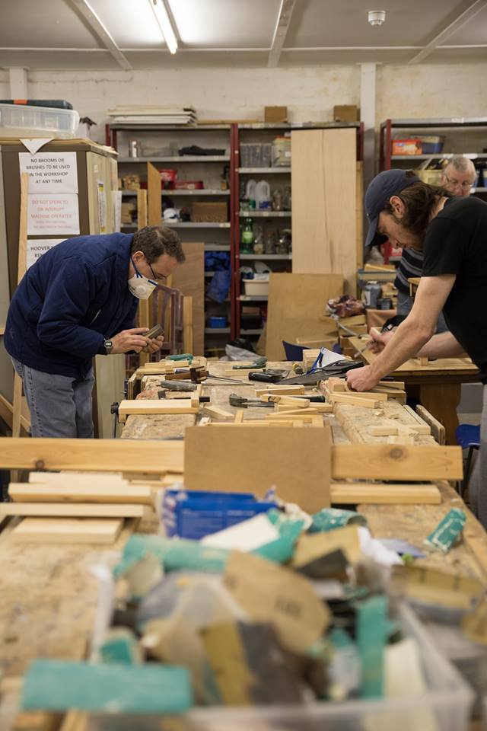

Management structure

The Chief Executive, Naomi Ridley, has held this position since 2002. During this time, she redeveloped the Hastings HFS site, set up the training provision, increased and diversified earned income exponentially and placed HFS on a firm financial footing. Naomi established that there was significant demand for HFS services in Bexhill/Rother and purchased the Bexhill site that we are looking to redevelop.
Naomi is the strategic driver of the organisation, but ensures she retains day to day understanding of operations and staffing. Under her management there is a coherent and exciting vision for the organisation which contributes significantly to regeneration in the area. Naomi works with the Board of Trustees and staff to set priorities and an Action Plan (on a rolling 3-year delivery). She reports regularly to the Board against targets agreed in the Action Plan.
Deputy Chief Executive, Andrew Burnett manages day to day operations, book-keeping and finances. He has undertaken AAT training in book-keeping and payroll.
Angie Lowe manages project delivery which includes training programmes and work with the volunteers. She has extensive experience of supporting people who are not able to compete in the labour market into jobs.
The Management team is assisted by Mary Denning, former Head of Economic Development at Hastings Borough Council and Policy Advisor to East Sussex Fire and Rescue Service. Mary’s expertise in project management, research, monitoring and evaluation contribute to project development, management and evaluation.

Governance
HFS has a Board of Trustees with a wide range of skills including finance, IT, personnel, project management, business support, training, equal opportunities and understanding the needs of vulnerable people.
The Board meets regularly to consider financial and trading information as well as strategic planning. Trustees examine the needs for funding, gaps in provision and current projects. They all live and work in the area and have in-depth knowledge of local conditions and challenges. The expertise of Trustees provides scrutiny and support for the Chief Executive.
The Board develops an Action Plan with the Chief Executive and staff, on a rolling three-year basis. This includes new projects to meet local need and income generation. The objectives of the Plan are carefully aligned with the overall aims of the organisation and the Plan is used to provide a framework for the delivery of the objectives.
There is a Finance Sub-Committee which meets regularly in advance of the main Board meeting. The Sub-committee monitors sales, income from grants and the value for money which HFS provides as well as providing advice and support to the Chief Executive in relation to large projects and financial strategy.
Board members with specialist expertise actively take on additional responsibilities, for example:
- Claire Davies has given assistance with planning for GDPR compliance and IT systems
- Jacky Everard has supported with HR issues
- Mike Denning has provided Observations of HFS training sessions to assess the quality of teaching, give tutors support and feedback, and help staff prepare for potential Ofsted inspections
The Board has scrutinised the planning for the Bexhill redevelopment at every stage. Trustees have used influence as well as expertise to promote the scheme locally and to act as champions in the business and other communities.
HFS Board members | Expertise and Skills
Name | Finance | Business | IT | Project management | Strategic and political | Personnel &  HR | Training & education | Local economic challenges | Community
Jacky Everard
Chief Executive, HARC
(local advice charity)
Claire Davies
Consultant project manager
Mike Denning
Retired Deputy Headteacher
Mike Bushell
Optivo Housing Association
Melanie Selley
Education Training Consortium
Brett Maclean
Business & Publicity Consultant
Cllr Maurice Watson
Rother District Council
Cllr Nigel Sinden
Hastings Borough Council

Successes
Employability:
HFS has an outstanding track record for helping people with complex barriers and diverse backgrounds into work. Our practical, work-based approach to building the skills and confidence of participants, coupled with our skilled Support Worker to tailor individual support, is very successful. HFS has also participated in several schemes that have offered paid work with training for unemployed people and demonstrated a 75% success rate.

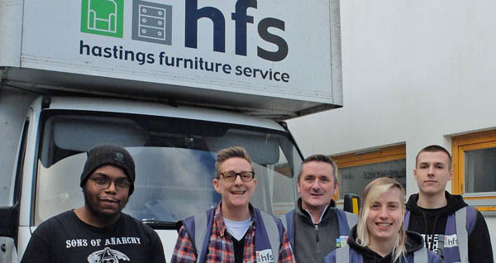

Staff development and stability:
HFS invests in staff training and development so that the team’s skills keep pace with the growth of the organisation, retaining key staff members such as the Deputy CEO, store managers and CEO for 10-20 years’ service.

Quality:
HFS training provision at HFS has an excellent local reputation and learner feedback. Our tutors were rated “Exemplary” by the inspector from our national awarding body, NCFE.

Building development:
In 2006 HFS Hastings was operating from a former glassmaker’s warehouse. The building was semi-derelict and while it was able to store donated furniture, retailing on the site was very challenging. There was no space for display and customers were obliged to pick their way through what must have seemed like an obstacle course if they wanted to view the limited range of furniture that HFS was able to offer.
HFS owns the site (as it does in Bexhill) and a funding package was put together to redevelop the site. Temporary premises were rented which were accessible to existing and potential customers so our services were maintained through the rebuild. The same architect and project manager carried out the work (and are retained for the Bexhill redevelopment).
The redevelopment was delivered to time and within budget thanks to vigilant project management, careful budgeting and the intensive involvement of the Chief Executive. The redevelopment was a significant undertaking which was successful on every measure.
HFS Hastings is now a light, modern and practical place for people to shop, train and work. The development doubled the floorspace and established training facilities. It has helped to enhance a disadvantaged area of Hastings and turnover rose by 30% in the first full year of trading.
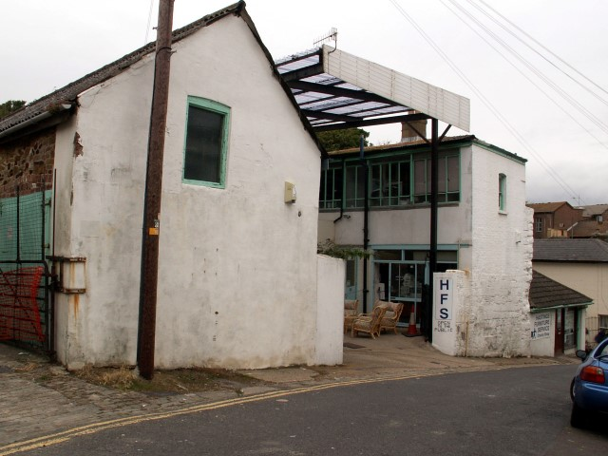
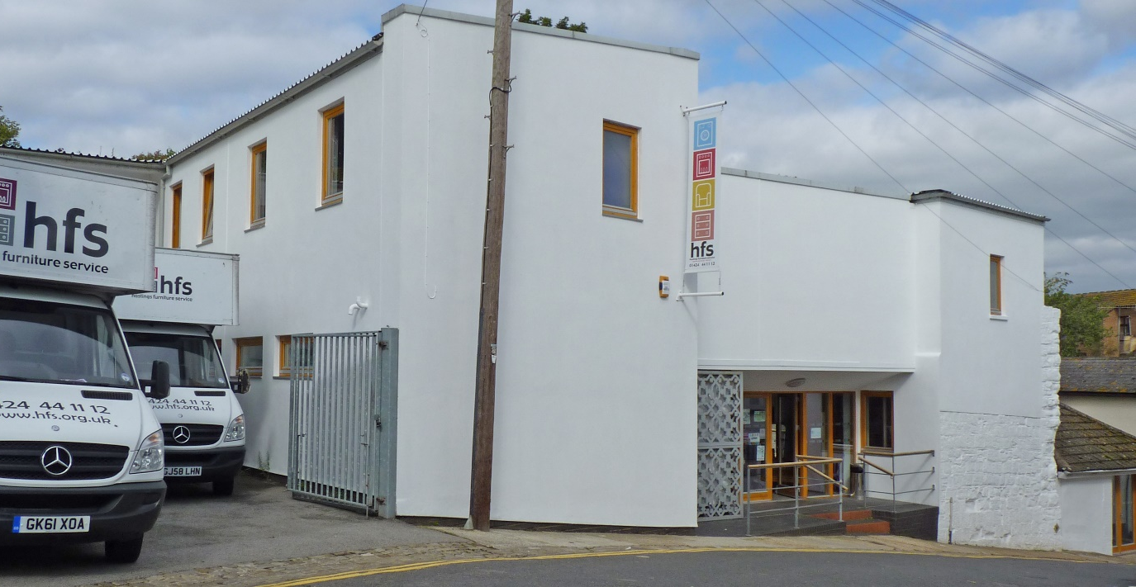
HFS Hastings before and after redevelopment:

Learning applied to this project
We have made some modifications in our approach for this project. These are:
- More intensive involvement of our Board members. In 2006 our Board was enthusiastic and devoted but lacked the skills to offer much practical assistance to the project. Our Board now has the expertise to provide expert support and scrutiny throughout the project.
- Project management tools and software have progressed over time and the redevelopment will benefit from even more timely and accurate information. This will help to ensure both timetable and budgets are adhered to.
- Risk management has also become more sophisticated and the redevelopment will benefit from this additional awareness
3: Project background

The project
The project redevelops an unsightly and dilapidated former garage and petrol station into a retail and workspace hub creating and safeguarding 179 jobs.

Aims of the redevelopment
- Create a hub of efficient new workspace units for small businesses and start-ups to create jobs and training opportunities
- Enable the existing HFS social enterprise to continue to grow, extending the services provided and opportunities available for training and jobs
- Contribute substantially to the economic and physical regeneration of Bexhill

Objectives of redevelopment
- Create opportunities for start-ups, micro and small businesses to rent low cost, high quality, supportive business space in order to develop their enterprises and create opportunities for local residents
- Provide employment, training and volunteering opportunities for more people who are vulnerable and disadvantaged
- Provide people in Bexhill, Rother and St Leonards with a wider range of low cost, quality furniture and household goods in a welcoming and accessible building
- Generate earned income to sustain projects so they are not dependent on grants
- Reduce the amount of furniture and household items going to waste in landfill sites in Hastings and Rother

What we will do
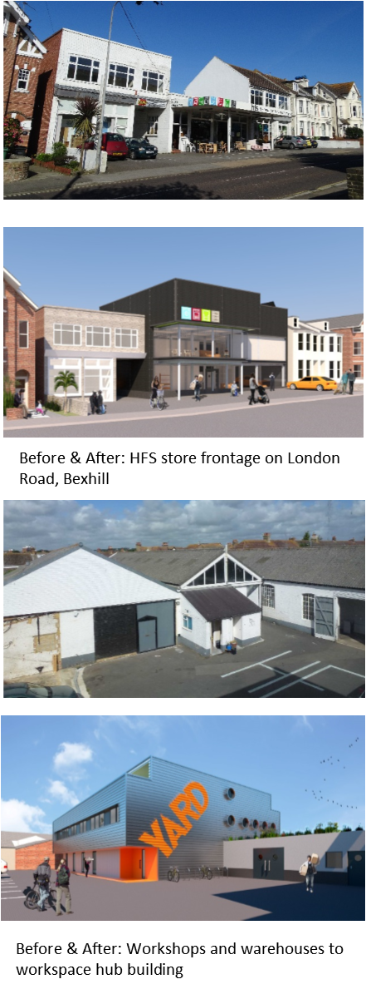
We will redevelop the site to create a modern, efficient building that provides supportive space for small enterprises and start-ups. This workspace hub will comprise 18 units of workspace 20-50m², a rent-a-desk co-working space and communal facilities for breaks, meetings and training. The hub has been designed to provide light, comfortable work environments set around wide central spaces and shared facilities to encourage natural networking, peer support and collaboration.

HFS envisages that a dedicated support worker for the hub will be essential. The role would include:
- Marketing the Hub, recruiting and supporting new and potential tenants
- Organising peer support events within the Hub
- Mentoring tenants and signposting them to suitable business support services where needed
- Organising and promoting collaborative events such as open studios, sales of work
- Encouraging tenants to consider ways in which they can create opportunities for local residents (e.g. inviting an Apprenticeship co-ordinator to give a talk at a Hub event)
- Ensuring the building is maintained to a high standard

The units will be particularly attractive to creative and digital businesses. This is a growing sector in the area and considerable research has been done to ensure that the project creates spaces that will serve and support the continued development of enterprises in this sector (see Sector Research below).
Alongside this, the redevelopment of the HFS retail store on the site will enable us to reuse more goods, help more low-income households in the area, attract additional customers and increase training placements. Increased sales income will support employment costs for HFS staff.

Site layout
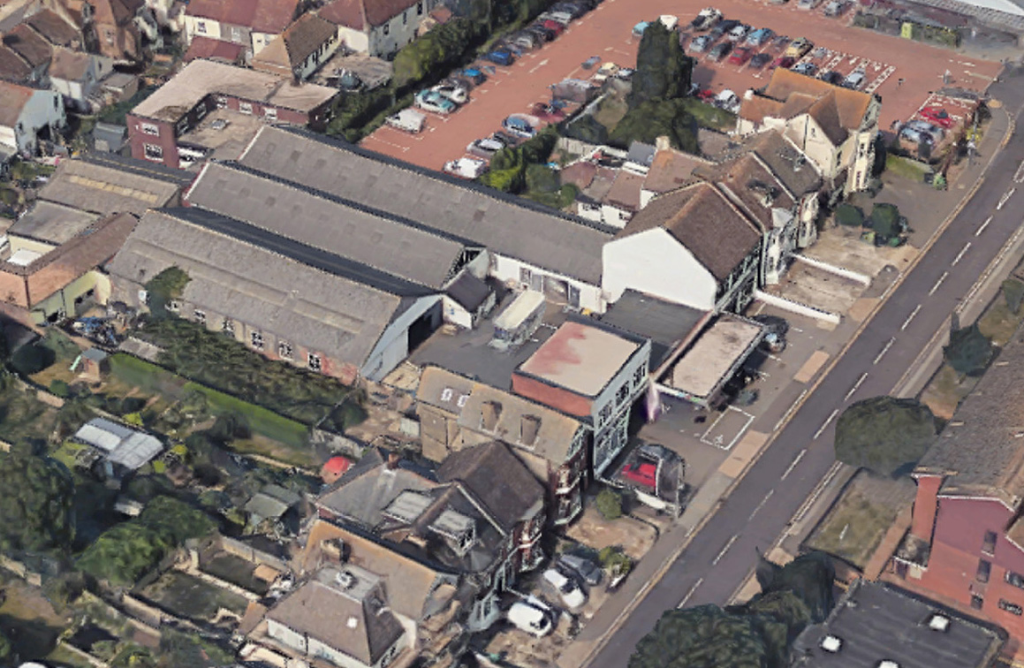
The site layout will change as the redevelopment creates two connected 3-storey buildings with a larger rear courtyard to provide parking for workspace units.
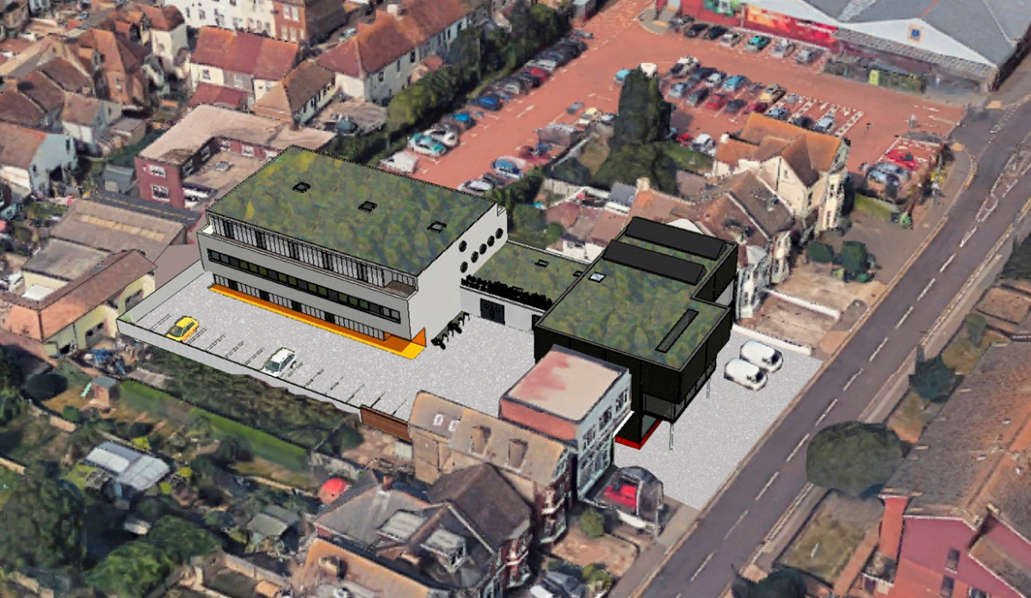
Existing site: HFS store and single-storey warehouses
New development: larger store, workspace hub, more parking, green roof

Self-sustaining social enterprise development
Rental income from the units will be maintained at affordable rates and thus primarily cover the costs of maintaining the building, utilities, broadband and the dedicated support worker.
Our Cash-Flow Forecast demonstrates that the income earned by the hub will cover these ongoing running costs at a realistic occupancy rate. It is not projected to make a profit.
HFS can provide sustainable supportive and affordable workspaces because we are a social enterprise; we can undertake projects that will cover costs but not make a profit, and our objective is to deliver social value as well as economic value for our community.
If any surplus income is generated it will be reinvested in the HFS long term ambition of self-sufficiency for projects, rather than grant dependency. HFS is a social enterprise and registered charity so it has an “asset lock”, which means that any surplus generated is ploughed back into the services HFS provides in the community, for example running additional training courses or hiring an unemployed person as an Apprentice to help in the HFS store.

Project Background
The redevelopment of the HFS Hastings site enabled the social enterprise to help more customers, develop training services, generate increased earned income to reduce grant dependency and repay the mortgage on the site. Owning the rebuilt Hastings building outright enabled HFS to consider expanding to a second site and research was undertaken to ascertain unmet need in the area.
Bexhill was identified as an area with significant and increasing deprivation, with a large number of households dependent on welfare and high levels of unemployment. Residents reported that the cost of transport deterred them from using HFS services in Hastings. Therefore, HFS searched for premises that were accessible to the deprived neighbourhoods of the town and large enough to establish a store for Bexhill.
The premises in London Road, a former Renault garage, on the main road into the town, is accessible to the most deprived neighbourhoods and offered space enough to start a store and also potential to develop further services and host other opportunities. HFS invested a large deposit and the remaining balance was loaned by Rother District Council and Lloyds bank.
HFS quickly became embedded in the community and business sectors of the town. Over 1,000 households used the service in the first year. From the outset there were enquiries about renting some of the buildings at the rear of the site.
Initially, HFS encouraged a local College to rent the former repair garages to set up motor vehicle repair courses which were not available in the area. These were so popular and successful, particularly with “hard to reach” learners, that the College expanded and relocated the provision to a larger site.
Most of the enquiries about renting space were from smaller concerns and start-ups. Consequently, HFS partitioned one of the garages into 4 smaller units and discovered there was a steady demand for these spaces, despite their rudimentary facilities.
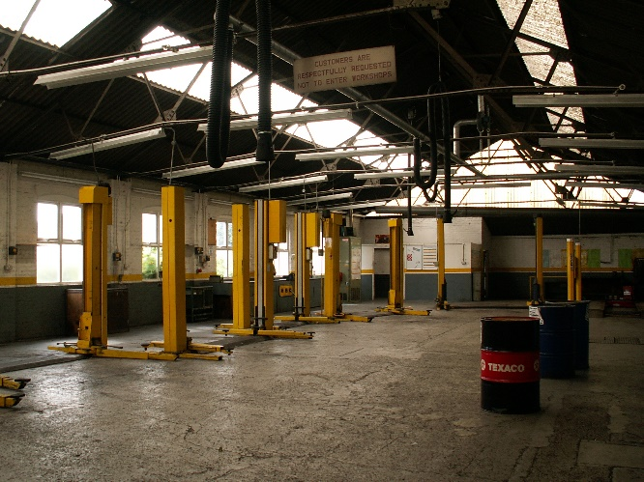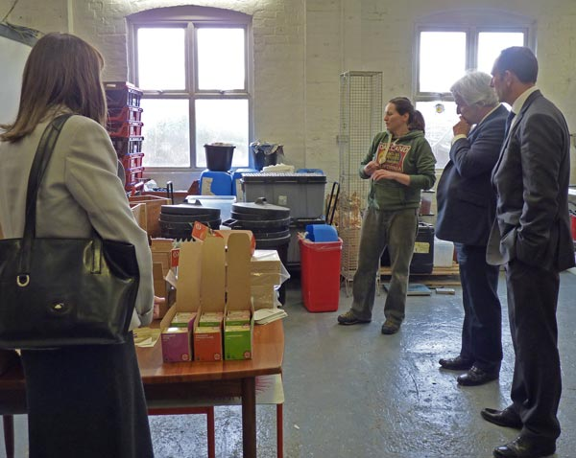
This prompted HFS to commission a feasibility study into developing the site to provide a hub of affordable workspaces that could offer the working environment and support to enable many more small enterprises to thrive.

Feasibility Study
A Feasibility Study was conducted by Neil Choudhury Architects in June 2016. It found that it would be possible to construct both a larger, more modern store for HFS and a workspace hub on the site, and also provide additional parking spaces in the courtyard. The Study is attached.
It included:
- Review of precedent
- Outline assessment of structural capacity
- Existing advice on constraints: Planning, Building Regulations, Party Walls
- Adjoining properties
- Indicative layouts
- Building massing and assessment of overshadowing
- Outline budget costs

Sector research
The feasibility study into the potential of the HFS site was carried out at the same time as a number of separate studies into the potential for creative and knowledge-based sector growth by East Sussex County Council, Rother District council and Bexhill Contemporary outlined below and attached. At a regional level, the South East Local Enterprise Partnership (SELEP) identified the creative and digital sector as a key area for growth, and also identified some specific localised challenges or gaps in mainstream provision for enterprise support and development (see section 4 for more detail). At the same time DV8 was developing The Hive, a vocational training centre for the sector in the town. De La Warr Pavilion was defining its mission as a hub for the cultural sector. The organisations started to meet regularly to ensure that their work complemented each other and formed part of a larger strategy. Bexhill was becoming a growing centre for creative and cultural industries.
East Sussex County Council produced a Creative Workspace Enquiry Report and a Digital, Media and Creative Industries report in 2017. These demonstrated that the local sector is significant and growing more quickly than the rest of the economy (23% in the last 5 years). Enterprises in this sector are much more likely to be micro, with the majority having less than 5 employees. The Workspace enquiry found that there was significant interest in small workspaces and studios, including shared space and co-working (e.g. “rent-a-desk” space).
Rother District council commissioned an Economic Impact Study into Creative Workspace in 2018 which identified the HFS project as being the most advanced potential hub in the area. It also identified key ingredients for the success of workspace projects, which have informed our project planning.
Bexhill Contemporary, in partnership with De La Warr Pavilion, produced a proposal to create affordable workspaces for creatives. The report includes market analysis and recommendations about the size and type of workspaces that have informed our project planning.
We researched workspace hubs in the area, visiting several and interviewing the owners and tenants.
We also researched the experiences of other organisations that specialise in developing and managing creative workspaces, including the size and design of their “ideal workspace” which influenced our designs. A number of similar projects are outlined in a book produced by Acme Studios and Central Saint Martins, including purpose-built creative workspace hubs like High House, which influenced the sizes of our units.

Consultations and surveys
HFS had always hoped to redevelop the retail element of the site, but the feasibility study and evidence (both empirical and quantitative) showed that there was potential to develop the site to also meet the demand from micro-businesses and start-ups for affordable space.
This led to extensive informal consultations with Rother District Council’s economic development team, Members and Executive, the Bexhill Forward Town Team and Coastal Communities Team, community groups, creative sector delivery organisations, business support bodies including the Chamber of Commerce, Federation of Small Business and Locate East Sussex, neighbouring properties, East Sussex County Council and Hastings Borough Council.
HFS undertook a survey of small and creative enterprises online and in person, attending events to mark the end of the Coastal Currents arts festival to meet creatives and interview them about their workspace needs. The findings are outlined in more detail in section 4 below.
The response was overwhelmingly positive. Each interest group had specific aims and the HFS proposals for the redevelopment helped each group to deliver their ambitions at least in part. Local organisations such as the Chamber of Commerce, Council Estates Management team, creative and digital training providers, business support organisations all confirmed the need for affordable workspace units (see letters of support attached).
The plans were developed and stakeholders and neighbours were invited to an Open Day at the site to discuss the proposals. More formal consultation was organised to move the project forward while keeping stakeholders engaged and informed, and the project obtained Full Planning Permission in 2018.

4: Strategic context

Gaps in provision identified through consultation or research
Our consultations with local stakeholders and individuals, and the research by the local authorities, identified specific local gaps in provision:
- Affordable local workspace with flexible terms in supportive settings
- Centrally-located workspaces that are accessible by foot or public transport
- Practical, informal and peer support for new enterprises
- Affordable office furniture
- Need for core HFS services, training, employability opportunities
- Job opportunities in higher-value, year-round enterprises

Our findings echo some of the “market failures” identified by SELEP and referenced in the CHART strategy for Hastings and Bexhill:
Market Failure | How the project addresses this
Lack of local mainstream delivery infrastructure and content to both engage and retain low-skill beneficiaries | We will create a hub of workspaces that are accessible to the most deprived areas, are affordable, have few barriers to entry for people starting out in business, have in-built informal support mechanisms that are sustainable so that beneficiaries are retained.
Lack of audience-appropriate information targeted on the difficult to reach | The practical and supportive nature of the workspace hub will be communicated in appropriate language.  The co-ordinator will attend outreach events and liaise with other local projects (particularly those around Entrepreneurship) to engage and encourage beneficiaries who may be seen as hard-to-reach by mainstream providers. For example, people with poor credit history who cannot borrow to start a business, or people who have a perfectly sensible self-employment or small business plan that they can communicate verbally but lack the confidence and literacy skills to write a business plan or apply for start-up funding.
Mainstream provision difficulty in adequately identifying and responding to some very local economic, social and geographic barriers to the labour market | HFS has a 30-year track record of working with and for local residents in deprived areas who are seen as hard-to-reach by mainstream providers.  We understand the critical local issues and barriers to taking part that affect our service users, which is why we have designed our project in a way that reduces geographic, financial and social barriers to starting up and provides the kind of ongoing support that people actually want, rather than a time-limited course, impersonal handbook or website.
Insufficient private sector investment in commercial/public sites & buildings and entrepreneurs due to perceived/actual lack of required investment return/uplift value, lack of security against loans, inappropriate/poor business & investment plans by those seeking private sector backing/support | There is significant local need for affordable, flexible workspaces to enable fragile small enterprises and self-employed people to start up and grow, to create jobs for the large number of unemployed residents, but very little suitable local provision.  Most new-build and commercial workspace is not affordable. Cheaper commercial spaces often offer poor working conditions (or tenants have to fund repairs) and require a long lease agreement.  This project would not be undertaken by a mainstream or commercial developer because neither the future rent income nor the increase in the site value would provide a profitable return on their investment. For the same reason, we are approaching funders rather than commercial lenders to support the development.  HFS can provide sustainable supportive and affordable workspaces because we are a social enterprise; we can undertake projects that will cover costs but not make a profit, and our objective is to deliver social value as well as economic value for our community.

In recent years, a range of industrial units and offices have been developed in Hastings and Bexhill. The new link road (between north Hastings and Bexhill) has opened up opportunities for commercial and residential builds. It might be supposed that with this level of provision, additional units would be superfluous. However, locally it has been impossible to meet demand for small industrial/commercial spaces at reasonable rents. Hastings Borough Council reports that its extensive portfolio of industrial units is fully occupied, including the workspace units it developed 5 years ago. Rother District Council’s workspaces are also full. Locate East Sussex reports that enquiries are at a record high.
The prohibitive price of property (both residential and commercial) in London and other areas of the south-east has led to an exodus, particularly of micro and creative businesses, to coastal areas. Brighton quickly became unaffordable, and so Hastings, Margate and Folkestone have become the new centres of creativity and enterprise. In addition, home-grown creative talent nurtured by DV8 and local colleges needs space in which to develop their craft and business skills.
Our research shows that new creative enterprises find market rent levels unaffordable even in Hastings and Bexhill, where the average rent is lower than the rest of the South-East. Our social enterprise project can address this affordability issue sustainably to help local entrepreneurs get started and create jobs.

Links with other projects or strategies
The project is focused on the growing local creative and digital sector, which connects with work being done by De La Warr Pavilion and others in the Bexhill Creative Collective of organisations. The facilities created will also complement the work being commissioned by the CHART initiative (Community Led Local Development, managed by HBC).
The project also contributes to public realm improvements on the main thoroughfare for visitors to the town that are being planned by Rother and East Sussex Councils.
The project contributes to wide range of local strategies laid out in table below.
Strategy | HFS Redevelopment | Strategic Fit
Coastal Communities Fund | 179 FTE jobs will be created and/or sustained.  The redevelopment is central to the continued creation of indirect jobs in the area and its regeneration | Coastal communities will experience regeneration and economic growth through projects that directly or indirectly create sustainable jobs, and safeguard existing jobs.
Bexhill Forward – Bexhill’s Coastal Community Team | Supports London Road Gateway improvements  Training and volunteer placements are central to the future of the project | Improvements to the public realm in the main streets in the town centre  Addressing the need for employability and entrepreneurship training for young people  Affordable workspace for creative and digital sector
RDC Local Plan and Economic Regeneration Strategy | The redevelopment maximises the employment-space potential of the site and creates affordable workspaces for new enterprises.  The project also makes huge improvements to the buildings on London Road, a gateway road for Bexhill that is in need of improvement. | Site is designated for employment. RDC favours maintaining and increasing employment uses for the benefit of residents.  RDC and ESCC are committed to London Road Gateway regeneration
SELEP Strategic Economic Plan | Social enterprise creating jobs and business opportunities | Jobs and Innovation: Making the South east the capital of social enterprise
SELEP Cultural and Creative Prospectus | Creative businesses will be targeted by the Yard development | Future proofing creative jobs  Bexhill’s creative sector
East Sussex Growth Strategy | Yard is particularly suitable for technological and digital enterprise  Volunteering and training opportunities | Enabling business growth, particularly of ‘high value’ businesses  Quality of life  Meeting the skills needs of business. Supporting residents to reach their full potential
CHART (Connecting Hastings and Rother Together) Local Development Strategy | 179 jobs will be created or sustained.  The building contracts will ask for local people to be employed and trained  New employment and enterprise opportunities  Training and volunteering opportunities for those furthest from the labour market | Supporting the demand side in the local labour market  Growing the local economy Investing in assets for the future  Linking disadvantaged local people with developments in their localities, the availability of new employment and enterprise opportunities, increasing levels of work readiness
Hastings and Rother 6 point plan | Contributing to the regeneration of the Bexhill “Gateway”  Skills training  20 units for enterprise with support provided. | Urban renaissance  Skills  Enterprise growth
Cultural regeneration strategy | Yard ideally suited for creative businesses  Regeneration of Bexhill  Training | Live  Work  Visit  Invest
Anti-Poverty strategy | Low cost furniture and household goods help combat poverty and fight debt  Volunteering improves mental health | Education and Employment Health and Well-being  Housing
East Sussex Health and Wellbeing Strategy | Low cost, quality furnishings help to keep people safe and warm.  All volunteers get H&S and manual handling training  Volunteering stabilises and improves mental health  Many HFS volunteers have learning disabilities. | Enabling people of all ages to live healthy lives and have healthy lifestyles  Preventing and reducing falls, accidents and injuries  Enabling people to manage and maintain their mental health and wellbeing  Supporting those with special educational needs, disabilities and long-term conditions

How our project will complement existing provision
The different communities within Bexhill are tightly knit and share the same ambitions and values. It is therefore well known what different sectors are doing and how they intend to meet their needs in future.
RDC recognised the need for small business units some years ago and built on the old Sidley Goods Yard. There has been strong demand for those units and RDC expects the HFS incubators to complement and enhance the existing offer.
There is also complementarity in the following areas:
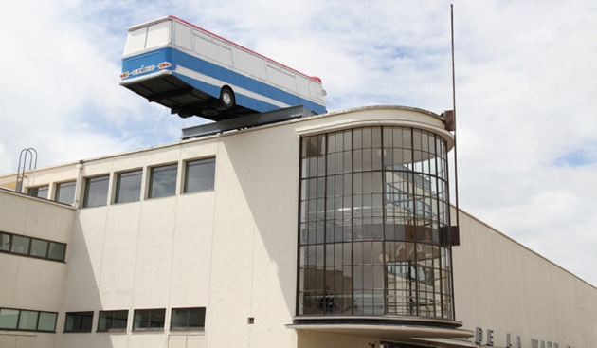
- Existing training in the creative sector by DV8, Bexhill College and other providers results in graduates needing space to develop their enterprises.
- The trend for creative industry practitioners relocating from more expensive areas could create more opportunities for local residents.
- Creative Collective, with De La Warr Pavilion at its centre, the Sackville Road creative quarter, DV8 training centre. The HFS redevelopment will provide studio space for artists working on projects with the DLWP and will help to develop local talent. In addition to the affordability of studio space, artists have found the light levels on the SE coast inspirational – from the time of Turner onwards.
- CHART (Connecting Hastings and Rother Together) will deliver regeneration opportunities across the area. Central Bexhill and Sidley are specific target neighbourhoods. CHART is part funded by European monies (ESiF and ERDF). The strategy emphasises employability and skills through regenerating the infrastructure and through encouraging entrepreneurship. The funding stream timing is over the same period
- The HFS redevelopment will offer business assistance at a basic level. This complements the experienced and able business support organisations in the area which offer training and learning for start-ups and more advanced courses for established enterprise.

Local Context: Bexhill
One of the drivers of persistent deprivation and market failure in coastal towns has been the reliance on tourism and a short visitor season. More traditional attempts to diversify the offer, lengthen the tourist season and attract more visitors have only been partially successful. The resulting economic reality has been low skill and low paid work albeit of a year-round type.
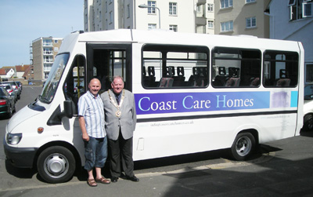
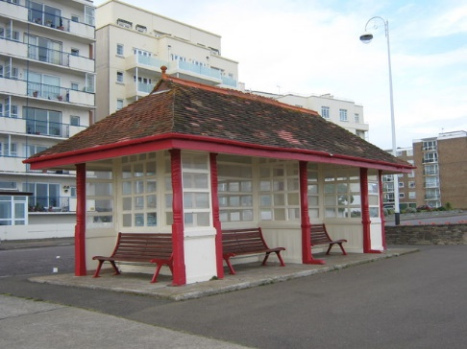
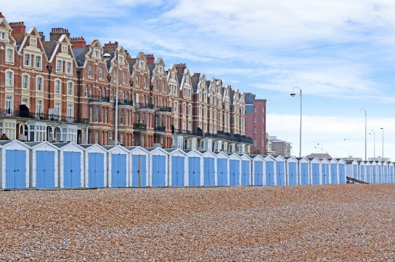
It has become increasingly important to refocus seaside economies to break away from these traditional models and to look at other ways of providing high skilled, desirable jobs which will inspire young people to become skilled and knowledgeable with real ambition.
Bexhill’s place in the south-east’s Creative Coast was cemented by the De La Warr Pavilion, a community asset already attracting 400,000 visitors a year, becoming a hub for the cultural and creative sector. DLWP is working with the Bexhill Creative Collective of organisations to promote and support the local creative sector, provide opportunities for people to develop creative enterprises, and build distinctive niche for Bexhill as a town that promotes local creativity.
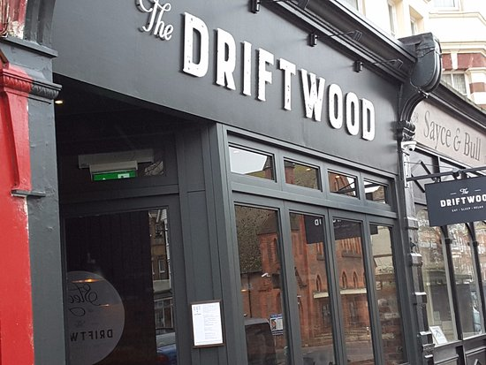
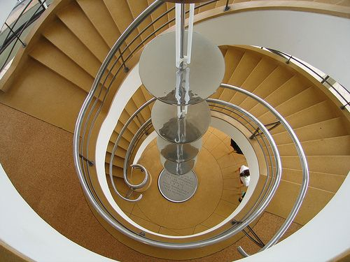
Bexhill is changing from being perceived as a sleepy place dominated by an ageing population to a lively, creative and ambitious town. This draws people in from across the south of England all year round – but the concept must evolve in order to retain interest. The HFS project will contribute to the necessary step-change which must take place to revitalise Bexhill.

Target Beneficiaries
The range of potential beneficiaries is wide – and this is one compelling reason for the development to take place.
The area has suffered deprivation and poverty with low skills and lower aspirations for many years. However, the persistent and deeply rooted issues relating to the weak local economy are well understood in the area. Because there is a shared understanding across all sectors (private business, statutory organisations, the third sector and community there has been a consistent strategic and operational approach to tackling the multiple disadvantages.
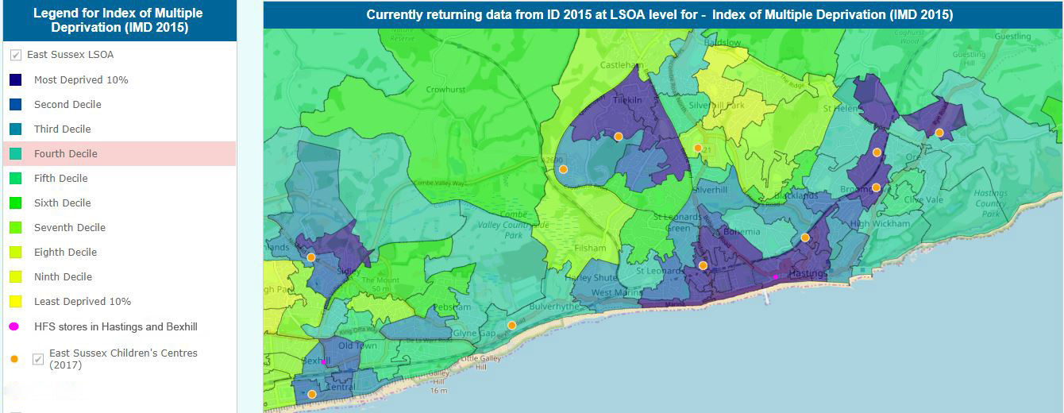
Over the years, a consensus has been reached by all stakeholders in the area that to start driving deprivation back on a long-term basis the following issues must be addressed consistently:
- Connectivity: road, rail and digital
- Physical regeneration
- Levels of education and skills
- Wage levels
There has been genuine and sustained effort to turn those significant disadvantages into opportunities. It has always been understood that the solutions to the multiple problems would be developed and implemented locally. Effective action always starts within the community while being aware of regional and national policies which may assist.
For example, because of the poor connectivity of the area, efforts have been made to stimulate and encourage artistic, creative and knowledge-based industries. The resulting creative training hub in Bexhill (described elsewhere in the document) has gone some way to revitalising the area and giving young people new career directions to which they can aspire.
Because levels of educational attainment and skills have been so low for so long, community-based learning and education is robust and effective. These organisations are able to work directly with employers and potential learners to determine local needs and then flexibly deliver against requirements in ways that larger organisations may aspire to but are unable to achieve.
Successive regeneration initiatives have sought to up-skill residents and open up opportunities. The most recent of these, CHART, is programming interventions to encourage entrepreneurship and skills development in the Hastings and Bexhill area that will run concurrently with this project. These interventions are mutually supportive and complementary.
It is clear that Hastings and Bexhill are working together to make substantial changes to the economic and social climate. There is still a very long way to go, but with the robust and clear direction of travel to which the whole community is committed, will enable genuine and lasting achievement.
The in-depth understanding of the issues we are all trying to address enables us to target this redevelopment accurately but over a wide range of potential beneficiaries.

Potential Employees and Entrepreneurs
The area has a job density level of 0.65 which shows that there are a third fewer vacancies than there are applicants to fill them. Rother has a job density level of 0.71 which is only marginally better. New jobs and training places created through this development will be helpful to local employers who are already noting skills shortages.
17% of the areas in Hastings are in the worst 1% nationally for skills and qualification levels and for young people, 28% are in the lowest decile. There are, consequently, a large number of potential workers who are currently unable to compete in the labour market and do not have the skills employers need.
Many of the people who are out of work have enduring mental health issues, poor physical health, and other problems such as lack of confidence, social capital and skills. They need supportive and flexible opportunities to enable them to become involved and active in the community, and move towards the labour market. HFS training and volunteering placements created by this project will enable upwards of 50 people each year to benefit from learning skills and understanding the needs of employers.
There are also people who are out of work who would love to start their own business or become self-employed but are unable to invest in starting up, or to borrow in order to do so, due to the long-term financial deprivation of their household. While a number of schemes aim to address this by raising the aspirations of the unemployed, this project aims to address these barriers in a practical and supportive way.
The micro businesses and start-ups in the workspace units will not only create jobs and training directly in the creative and knowledge-based sector, but will also benefit local service-based businesses from sandwich/coffee shops, to printers, office suppliers and retailers.

The needs of start-ups, micro businesses and identified demand levels
The project focuses on small/micro enterprises and self-employment because this is the dominant sector in our area and enterprises of this size form the majority of the creative and digital industries. Data from NOMIS shows that Rother has a higher level of micro-businesses (employing 0-9 people) at 91% than the south-east average of 89%.
Connectivity in the area is so poor that very few large companies choose to locate here. When they do, they do not always show commitment to the locality and residents or create well-paid jobs for local residents.
Once established, smaller organisations can flourish in our area. Business survival rates (from 2009) show that over a 5-year period, both Hastings (44%) and Rother (45%) do better than the UK average of 42%.

The needs of start-ups, micro businesses and identified demand levels – our research
HFS ran an online survey about the needs of local small businesses, start-ups and creatives. This was promoted by Let’s Do Business, Rother District Council, De La Warr Pavilion, FSB and other local contacts, encouraging anyone in need of workspace in the area to take part.
- 60% said they were likely to be looking for workspace in the next year while 40% were already looking.
- All the respondents were interested in a workspace local to Bexhill area with good transport links.
- In terms of business support, networking events and collaborations were valued most highly, but selling events, book-keeping and payroll were also important.
- All-inclusive rent and easy-in, easy-out terms were also popular.
- Most had a modest budget for their rent, under £5,000 a year. Just 20% respondents had a higher budget and none had more than £10,000 a year for rent.
- The size of units planned in the hub (25-45m sq) is appropriate for most respondents.

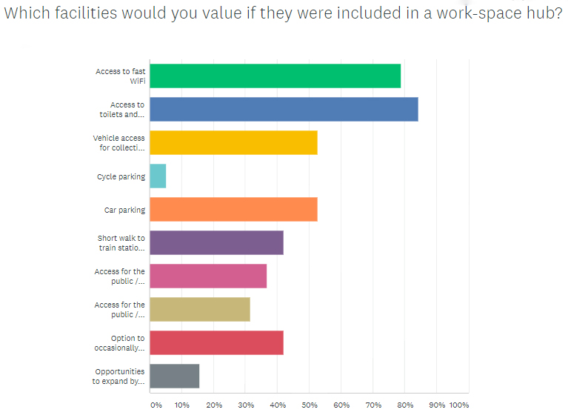
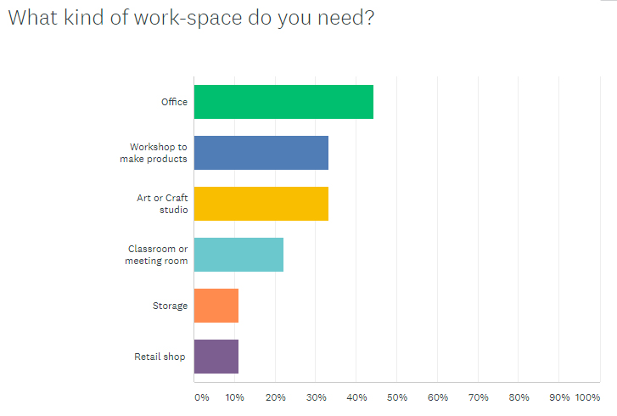
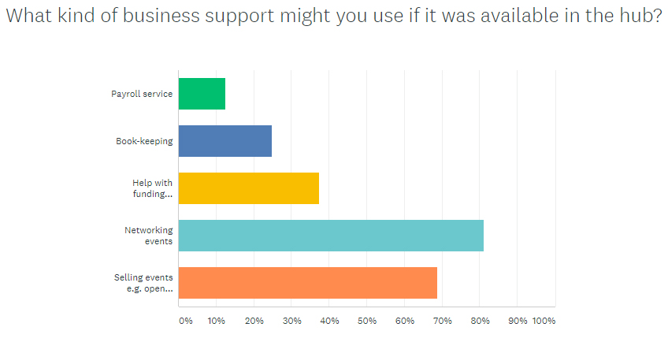
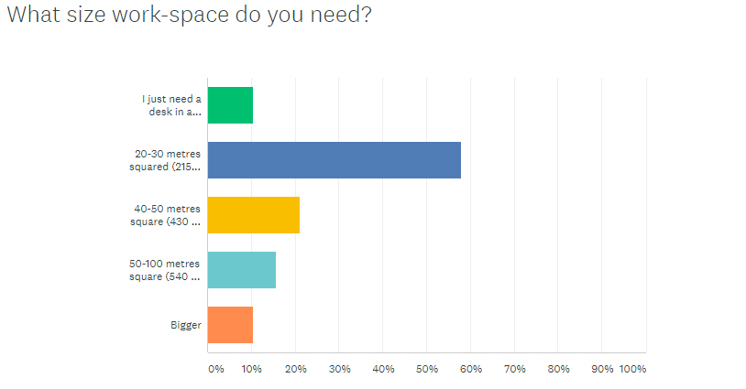

Need for HFS services
HFS exists primarily to help disadvantaged people on low incomes to furnish their homes. The HFS Bexhill “catchment” area (from where it draws its customers) is principally in Bexhill, north Hastings and western St Leonards. All these areas are in the 30% most deprived nationally.
Central Bexhill has significant child poverty (worst 10% nationally). Sidley, another area of Bexhill, experiences substantial and long-standing deprivation levels. Parts of the area are in the bottom 5% nationally for income, employment, education and skills and child poverty.
In north and west Hastings, deprivation levels are very severe, even in comparison with the levels of disadvantage in Sidley and Bexhill. The data for an area in Baird ward (north Hastings) reveals the truly shocking levels of poverty and disadvantage in the area:
- Worst 1% overall deprivation (89th ranked nationally out of 32,844 areas)
- Worst 1% nationally for income (11th), employment, education and skills (112th), health deprivation and disability, child poverty, older people’s poverty, children (107th) and adult education attainment
- Worst 20% for levels of crime
Unfortunately, this area of Baird ward is not an isolated pocket of extreme deprivation. None of the areas in Hastings which are nearest to the HFS Bexhill site are anything other than appallingly disadvantaged. They are all in the most deprived 2% nationally.
Repeated and sustained cuts to welfare and in-work benefits coupled with extremely low wages which do not increase have left many people with no resilience in the face of economic setbacks. The “success” of payday lenders and “Buy to own” organisations have led to a sharp rise in debt nationally.
HFS is able to offer quality household goods and furniture at affordable prices. This helps to ensure that high interest loans are the last, not the first, resort for people in poverty in the area.
The deprivation levels show no sign of impacting less severely and remain devastating on households and families. It is therefore necessary to be able to source more re-usable furniture, store it, display it more attractively and increase footfall and turnover for the benefit of the organisation and its customers.
The project supports the extension of core HFS activities which play a part in addressing the poverty and deprivation that prevents many local residents from playing a full part in the community and economy in the following ways:
- Local low-income households can access a choice of heavily-discounted furniture and electrical goods with which to furnish their homes.
- Free delivery reduces costs for low-income households and makes the service more accessible for those who could not physically lift and move the items for themselves.
- Affordable furniture helps vulnerable low-income households to access accommodation and make it into a home, reducing homelessness, sustaining tenancies and reducing voids.
- HFS supports unemployed adults with complex needs to gain real-workplace experience in the store and helping with deliveries and collections.
- Training courses and volunteering opportunities help people experiencing poverty, isolation and health issues to start to engage with activities outside the home, make social contact with others, learn workplace etiquette and progress into further education and employment.
HFS has carried out surveys of current customers and of people in the catchment area who are likely to need the service in the future. Among existing customers, while they were appreciative of the levels of customer service, the welcome and helpfulness of staff and very grateful for the discounts and free delivery, many wanted a very different experience while looking for their purchases. Overwhelmingly customers wanted a range of furniture, well- displayed and with space for the customer to look around.

Options Appraisal

A range of options have been considered carefully and discussed in depth before concluding that redevelopment of the existing site is the most appropriate way forward for the organisation as well as current and future customers.

Option A: non-intervention
Advantages
Non-intervention would save HFS the time and trouble of raising funds, managing the project itself and borrowing to meet any financial gap, but the disadvantages are significant.
Drawbacks and disadvantages:
- There would be no new start-up units, therefore no additional job creation.
- The Bexhill Creative Partnership has repeatedly set out the need for appropriate spaces for creative enterprises and start-ups to thrive. The lack of units would damage the case the partnership is building
- The existing buildings are dilapidated and will continue to deteriorate at an accelerated rate as they become even older.
- There would be an increased need for repairs, diverting HFS funds from positive services and projects and making the organisation less sustainable.
- The existing buildings would continue to age and do not offer the environment our staff, volunteers and customers deserve.
- It would become increasingly difficult to offer the training and volunteering activities that help people move into paid work.
- The street scene of London Road would remain dilapidated and HFS would be unable to contribute to the regeneration of Bexhill.
Option B: Relocating to a different town centre retail site
Advantages
Bexhill has a small but bustling shopping area in the centre of town. Relocation to a prime shopping area with potentially enhanced footfall is superficially attractive.
Drawbacks and disadvantages:
- It would not be possible to find a site large enough to develop the incubator spaces, which are designed to help new or micro businesses and create jobs, and extend the store.
- HFS is very unlikely to be able to buy a shop at a price comparable to that realised by any sale of the existing HFS Bexhill site
- Renting as an alternative is a retrograde step. While rents are low compared with the rest of the south east, the size of unit required would be more expensive to rent than the repayments on the outstanding loan for the Bexhill site.
- There are very few retail units in the town centre which would be big enough to accommodate HFS operations. Those which may be large enough are well established businesses with long leases
- Loading, unloading and parking for the vans requires a large space, preferably behind the store so items can be unloaded and assessed before customers view them. This would be difficult to find in a more central location and increases the cost of premises significantly.
- The local planning authority is satisfied with the redevelopment scheme and has been consulted at every step. A move to the town centre may not fit so easily with economic development, highways and regeneration policies.
- Although the current store is not in the central shopping area, it has 100ft frontage in a visible location on a major arterial road into the town, particularly for people coming into Bexhill via the link road and from Sidley.
- Parking is an issue in all town centres. A proportion of HFS customers come in from rural areas where public transport is almost non-existent. These customers often combine other shopping with a visit to HFS. London Road is also served by buses from Sidley and Central St Leonards. Currently the proximity of a discount supermarket to the HFS site is seen by many customers as a benefit. While parking is limited on the HFS site, there are residential roads around the area where parking for 2 hours is possible and the forecourt allows residents and house clearance companies to drop off and pick up donations and purchases easily, often on their way to the tip with items that are not reusable. These donations may not come to HFS if the store moved to a location with poorer access.
Option C: Relocating to an industrial unit at the edge of Bexhill
Advantages
- There would be adequate space for domestic and office furniture and other HFS activities
- Leasing or rental costs for an industrial unit would be lower than for a town centre retail site
- The parking needs of customers could be accommodated and it would not cost potential users of the service
- Loading and unloading would be relatively straightforward for staff and storage of vans would also be available
Drawbacks and disadvantages
- A significant marketing campaign to publicise the whereabouts of the new HFS facility would have to be imaginative and sustained. This would incur ongoing costs and still may not maintain the profile of the enterprise.
- If the site could not be adequately publicised, footfall and sales would decrease markedly and this would adversely affect HFS’ ability to deliver its aims.
- Many HFS customers rely on public transport – which is relatively reliable in more populated areas and buses, for example, do not go through the industrial estates in Bexhill with any frequency (if at all). This would require people, who may have mobility problems, to walk some distance and potentially vulnerable people such as DV survivors to visit an unsafe, insolate location alone?
- Many lower-cost industrial warehouses do not have Planning Permission for retail use and this cannot easily be sought due to Employment Land Retention policies.

The renting of an industrial site is an option when looking at temporary facilities during the redevelopment process.
Option D: Selling the existing site and developing a purpose-built facility elsewhere in the town
Advantages
- If a suitable site could be found, some of the limitations of the current site would be overcome, the retail space and the number of incubator units could be maximised.
Drawbacks and disadvantages
- The existing site is ideally situated (see above)
- Commercial town centre sites are generally smaller than the existing site and more expensive.
- Identifying an ideal alternative site is not likely to be possible. Any site would have both benefits and drawbacks. The disadvantages are likely to outweigh the benefits if the expense of changing plans is factored into calculations.
- Selling the existing site would be complex. Planning permission is now in place for our specific redevelopment and if a prospective purchaser wanted the site for residential units, for example, the cost and time in making those changes may deter a sale.
- Designs and architectural drawings have been completed, neighbours and the community have been consulted on the changes and the new development meets HFS needs
- RVA is already in situ. Any further relocation would have to be negotiated with them.
- There is no evidence that the existing site is worth any more now than when HFS purchased it. Any receipt from its sale would have to clear the existing purchase loan before any balance could be used to fund the purchase and fitting-out of another site.
- There is good footfall and high recognition of HFS among potential customers at present. The same arguments about moving to another location are applicable here.
Option E: Closing the Bexhill site and selling it, concentrating all activity in Hastings
Advantages
- If a buyer could be found, the Bexhill site could be sold, and the capital receipt used to redeem borrowing and invest in the Hastings service
- There would be economies of scale. Staff and running costs would be reduced, leading to fewer outgoings and reduced overheads.
Drawbacks and disadvantages
- The incubator units would not be a viable option at the Hastings site.
- Sales and footfall at the Bexhill store are both high. Prior to the opening of the new store in 2008 there were as few as 100 Bexhill households using the Hastings store to buy their furniture. The volume of donations was low enough to be dealt with in 3 mornings each week. In the first year of operation the Bexhill store served over 1,000 Bexhill residents and needed a full-time van to handle the volume of collections and deliveries.
- In 2014-15, the Bexhill store made sales of approx. £120,000, and saved 120 tonnes of furniture and domestic appliances from going to waste.
- The Hastings site has already been extended as much as it could be, and the store is already operating to capacity in terms of furniture storage, so there would be less space for displaying furniture and domestic appliances. Customers would therefore get less, not more, choice.
- More furniture would go to landfill as HFS would have to limit collections depending on the space available at the Hastings store.
- It would be impossible to accommodate the office furniture at Hastings, and so an additional store might have to be sourced – or the office furniture venture abandoned.
- Customers from Bexhill, rural Rother, north Hastings and western St Leonards who currently find the Bexhill shop convenient and accessible will have to come to Hastings where parking is scarce and expensive.
- While public transport makes Hastings relatively accessible, it is expensive and not always reliable.
- RVA have chosen to locate to HFS Bexhill as there are significant advantages for many of their member organisations and their clientele in having the domestic and office furniture sales available.
- If RVA were to be asked to move, it would have to be compensated for the expense of relocating and for the refurbishments the organisation undertook prior to taking up occupancy. This would reduce any receipt from a potential sale of the site
- Planning permission has already been gained for the Bexhill site. The cost of this and the architect’s plans will not be recouped and would have to be set against any capital receipt
- Fewer staff would be required and redundancies would result
- There would not be enough space in the HFS Hastings yard for the existing vans
- Rother District Council has been supportive to HFS and values the Bexhill site, seeing it as a very positive service for disadvantaged residents as well as a contribution to its environmental agenda. The relationship with RDC has been beneficial to both organisations and both would wish it to continue.
- If a buyer could not be found, no additional monies would accrue to HFS and the income form the Bexhill site would no longer contribute to HFS financially. There will be a cost in securing the site while waiting for it to be sold.
- The hill and narrow road on which HFS Hastings is situated is not as accessible as the existing Bexhill site and is not visible to passers-by. This is not an issue for Hastings residents as they know the site and its location, but people from Bexhill might struggle to find the shop.
Option F: Share premises and costs with a charitable or similar organisation which raises funds through a retail outlet
Advantages
- The Bexhill site could be sold (if a buyer could be found), and the capital receipt used to redeem borrowing and to invest in the Hastings site
- There would be economies of scale. Staff and running costs would be reduced, leading to fewer outgoings and reduced overheads.
Drawbacks and disadvantages
- HFS is likely to be in direct competition with charities which have shops in Bexhill.
- The HFS “brand” would be diluted by such a venture. Currently, brand recognition is strong among customers, donors and a range of organisations in the area. The ethos of the organisation is widely admired and if this was to be eroded, the regard for HFS may also decline.
- There is a risk of policies diverging and this could lead to fundamental disagreements (eg pricing, sourcing of goods etc.)
- If the relationship ended, broke down or the partner charity decided to abandon any retail function, HFS would be left with premises it did not choose and expenses it may not be able to afford.
- If one partner consistently outsold the other, there would be tensions.
- There would be a need for fewer staff and volunteers thus resulting in redundancies and reduced opportunities for volunteers.
Option G: CHOSEN OPTION
Redevelopment of the site to provide social enterprise retail and workspace hub
Advantages
- The redeveloped site would be a community asset, not only for HFS core service users but for the growing creative and digital sector.
- The redeveloped site would create jobs, services and opportunities, in line with HFS objectives as a charity.
- The site is already owned by HFS so redevelopment is within our control and scope.
- Planning Permission has been granted.
- RDC and other local stakeholders are fully supportive.
- Redevelopment aligns with a wide range of local and regional strategies.
Drawbacks and disadvantages
- The proposal is dependent on raising significant investment from funders.

Options Assessment approach

The approach used to consider the options available to HFS when looking at this redevelopment was chiefly concerned with:
- Creating opportunities for jobs and training
- Improving services for local residents
- Regeneration value to the area
- Strategic fit with social and economic policies and objectives of a range of statutory and NGO bodies

Reason for selecting chosen option

When the Board examined all other options, it was obvious that, provided the redevelopment could be financed, this was the only possible way forward which satisfied the objectives of the organisation to maximise the potential of the site to create opportunities and benefit the community. The was the additional advantage of supporting the regeneration of the area, including the burgeoning creative sector.
5: Project delivery

Project summary
The project is to develop a self-sustaining social enterprise store and start-up hub in Bexhill’s gateway London Road
The site is a former motor vehicle repair garage which HFS purchased in 2008. The buildings are dilapidated and do not make best use of the space available. The condition of the buildings and their layout present operating challenges. The plans redevelop this unsightly and dilapidated space into a retail and workspace hub creating and safeguarding 179 jobs

Workspace Hub
HFS has always seen the potential for the site hub to co-locate services that create opportunities for local residents and businesses.
Initially part of the site was leased to the local FE College to run motor vehicle repair courses – these proved so popular that the College has relocated to a larger facility. Currently a stand-alone building on site is leased to RVA and a workshop is rented to YMCA, providing courses for young people who have been excluded from schools. HFS plans to expand on this work to provide the space for more opportunities to be created.
RVA is the local community capacity-building organisation and has invested in refurbishing a building on the site with a 10-year lease. This means that RVA’s support services for social enterprises and local residents are available on-site, including payroll processing, training and funding advice.
The potential for joint working, partnerships and a higher profile within the developing local social enterprise sector, once affordable workspaces are available on-site, is considerable.
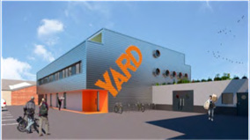

HFS store
HFS has grown and diversified on the site; it now includes a large office furniture element, as well as household furniture. The office furniture business needs much more display space in order to cope with demand for the service and generate more earned income for the social enterprise.
If the redevelopment can be funded, the increased display space for domestic and office furniture should result in increased trading and earned income. The rebuilding of the HFS Hastings store led to an immediate sales increase of 30%. This would result in HFS relying less on grant aid and becoming a more self-sustaining organisation, able to fund training for vulnerable and disadvantaged learners and volunteers.

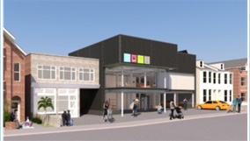

Please see Section 3 for more information about the project.

Project Location
London Road in Bexhill, where HFS Bexhill is situated, is the main gateway into a town which is undergoing an exciting transformation. London Road is key to RDC and ESCC’s plans to regenerate the area, helping it to shake off its undeserved reputation as a retirement town. London Road connects to the main A259 / A27 East-West, and also the North/South road linking Bexhill, Sidley and the north of St Leonards and Hastings. There is parking for visitors on the site forecourt (in addition to the parking for the workspace units in the rear courtyard).
The premises in London Road, a large former Renault garage, on the main road into the town, are accessible to the most deprived neighbourhoods. It is adjacent to a discount supermarket and this is beneficial to both organisations as a similar customer profile is attracted to both.
The premises are on the main road into Bexhill town centre, with good public transport links and 5 minutes’ walk from the railway station. This means that the customer catchment area is wide, including some of the more disadvantaged areas of Hastings as well as Bexhill and Rye.
The site is owned by HFS and plans have been approved for both the retail and workspace elements of the project.

Project delivery area
Project delivery will take place on site – but will have an impact over a much wider area. Low income customers are able to access HFS Bexhill from Hastings and Rother because of public transport connections and we have a policy of free delivery to people on low incomes and we refund the travel expenses of unemployed people who volunteer with HFS to move back into work.
The project will contribute to the development of the local creative and digital sector which is contributing significantly to the regeneration of the town – environmentally and economically. In the wake of the trailblazing creative industries (exemplified by DLWP, Hive, DV8 and others) galleries, shops and services are springing up, enlivening the town and making it a welcoming place to do business.
Young people who could only see their future away from the town or in entry level, low-paid work, are becoming aspirational – excited to see a future in arts related jobs in cutting edge industries such as game design, graphics, web-design and programming.
There are also opportunities for higher level support services such as accountancy and legal work. Local businesses with no direct connection to the creative sector will also benefit from fresh promotional ideas, helping them to sell more of their goods or services. However, the process has only just begun and the momentum must be retained and built on to transform the image and economy of Bexhill from sleepy, traditional retirement town to modern, thriving, creative community.
These are industries which require constant innovation and where flexibility and quick reaction time are key to success. This is one reason why the HFS incubator units will be so important. Fast moving businesses need flexible terms on which to lease studio space. It is possible for a “kitchen table” company to blossom very quickly and suddenly need more space and more staff. This makes the HFS offer particularly relevant and attractive.
HFS therefore is working with the most important elements of lasting economic growth and regeneration in Bexhill and its surrounding areas. By helping knowledge and skills-based practitioners as well as the most disadvantaged in our community, HFS is central to the future of Bexhill.

Job Creation

Direct jobs created and safeguarded 52
These are jobs which could not have existed without the redevelopment. They are new jobs reflecting the expansion and/or diversification of the business. HFS will be able to take on additional staff for the domestic and office retail functions. These are to be measured as full-time equivalents but will also be shown as posts. With so many jobs being part time in the current economy, it has become important to show the number of people and not just the hours they work.

Safeguarded jobs exist already but might not continue without the development. In addition, part time posts may become full time with increased activity such as trading.

The units themselves will be managed and administered through HFS. So some direct HFS jobs will be created as well as indirect employment through cleaning and maintenance contracts.

Indirect jobs created and safeguarded 11
Indirect jobs are created by other businesses and which exist because of the economic growth of a separate business (or because of opportunities attributable to that organisation). The HFS redevelopment provides a range of many different types of jobs and businesses that will benefit directly or indirectly. There is already an anchor tenant in place – Rother Voluntary Action which is a community capacity building organisation. It employs 11 staff and supports 183 organisations to help them grow and expand.

Construction 80
For more than a year, construction workers and their managers will be developing both the HFS retail and business space sites.

Construction of the units and redevelopment of the retail space will take over a year altogether. This will create or safeguard 75 jobs on site and 5 additional off-site staff

Business Units 40
The units will also create new employment as they are tenanted, but the calculation is more complex at this point.

The assumption is that each unit will provide 1 new job per year in line with the predicted occupancy rate. Allowing for the tenancy turnover and assuming that 33% of the occupants will have traded part time previously, the FTE will be calculated at 1.25 jobs per unit per year.

Suppliers and contractors 40
Suppliers of goods and services will also benefit both through increased turnover but will also need additional staff hours to meet increased demand in the area.

Training and volunteer places: 50 per year. This is based on current and projected capacity.

Sustainability of jobs

Supporting the regeneration of Bexhill
The HFS redevelopment is key to the continued regeneration of Bexhill. It is part of an orchestrated groundswell of community-led and focussed projects addressing every aspect of regeneration – economic, environmental and social. Jobs can only be truly sustainable when there are continuing opportunities and a vibrant marketplace. The project is a central part of these continuing ambitions.
Investing in infrastructure
The project develops infrastructure that will facilitate future investment and growth, not only for the Creative and Digital sector but for Bexhill as a whole by improving the gateway to the town.
Supporting growing businesses to sustain jobs
The project has embedded practical support to help tenant businesses create and sustain jobs. Businesses will be supported by the workspace co-ordinator post, have opportunities to support each other and network, and encouraged to create jobs and training for local residents. These supportive activities will be funded by rent income to the project in future years, so they are sustainable activities and not time-limited. The affordability and flexibility of the rent and terms will also help businesses sustain jobs.
Long-term impact
Overall, 179 jobs will be created and/or safeguarded during the first 18 months of the development. It is anticipated that the workspace units will have a relatively high “churn” as our support will enable micro businesses to expand, take on more staff and move on to larger premises. We have estimated that with a 1.5 tenant turnover, the hub will create 150 jobs over 5 years.
Increased productivity and efficiency
It is likely that the micro-businesses and start-ups attracted to the units will be “kitchen table” undertakings which are ready to move into customised premises. Productivity will be immediately enhanced as businesses are able to professionalise working practices, use a business address and concentrate on existing and new customers.
The increased productivity of the retail part of the site will help HFS to safeguard and create jobs and training opportunities.

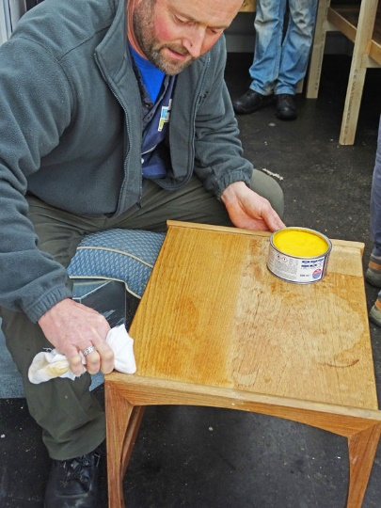
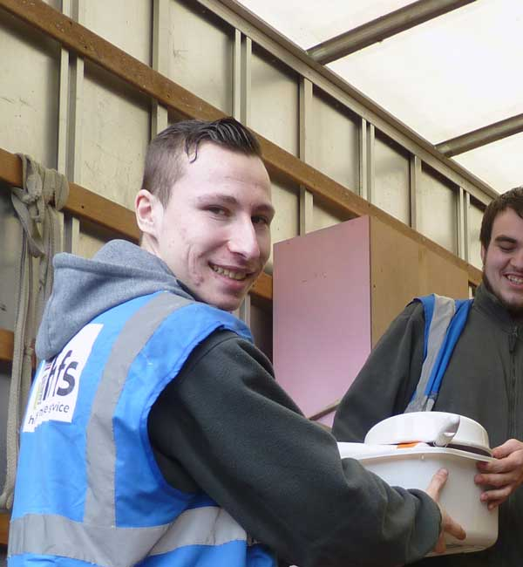
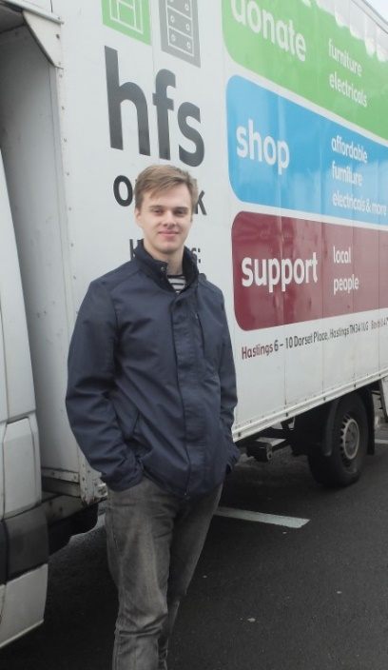
Support for beneficiaries
Currently HFS trains and supports over 40 volunteers each year, increasing the skills levels and employment rate of participants. They all have one or more significant barriers to their participation in the labour market, such as:
- Persistent and profound mental health issues
- Physical ill health and disability
- Learning difficulties
- Chaotic lifestyles or backgrounds
- Persistent and enduring poverty
- Low educational attainment
- No concept of workplace etiquette or the expectations of employers
We have an experienced and able Project Manager who works with beneficiaries on an individual basis. Many require help to resolve outstanding issues of homelessness, mental health issues, welfare benefit problems, budgeting, and a raft of barriers preventing them from taking their place in the workforce. Each volunteer or trainee has a personal development plan with targets which they help to set and are able to feel a real sense of achievement when they attain them.
HFS has an enviable track record of getting some 20% of volunteers who are long term unemployed into work. A further 15% annually re-connect with education or further training.
HFS has run several successful paid-work placement schemes (Labour Market Solutions, Future Jobs Fund, L-earn project), getting 75% participants into permanent employment or professional training. HFS continues to advocate for a Social Enterprise Apprenticeship scheme which would provide paid employment-with-training for unemployed people who are often disillusioned and discouraged at their inability to gain employment and do not have the skills employers require. The new workspace will provide a great work-based training experience.
We carried out an equalities impact assessment which showed us that the development could only assist people for whom the playing field is never level. We are determined that any temporary premises must be accessible by public transport, have convenient parking spaces and should have a lift if there are stairs. We serve a large number of families with young children and are conscious that buggy access is as important as wheelchair-friendly environments.
The full Equalities Impact Assessment is attached in Supporting Information.

6: Project resources

Project staff and their roles
The Chief Executive, Naomi Ridley, has held this position since 2002. During this time, she redeveloped the Hastings HFS site, set up the training provision, increased and diversified earned income exponentially and placed HFS on a firm financial footing. Naomi established that there was significant demand for HFS services in Bexhill/Rother and purchased the Bexhill site that we are looking to redevelop.
Naomi is the strategic driver of the organisation, but ensures she retains day to day understanding of operations and staffing. Under her management there is a coherent and exciting vision for the organisation which contributes significantly to regeneration in the area. Naomi works with the Board of Trustees and staff to set priorities and an Action Plan (on a rolling 3-year delivery). She reports regularly to the Board against targets agreed in the Action Plan.
Deputy Chief Executive, Andrew Burnett manages day to day operations, book-keeping and finances. He has undertaken AAT training in book-keeping and payroll.
The Management team is assisted by Mary Denning, former Head of Economic Development at Hastings Borough Council and Policy Advisor to East Sussex Fire and Rescue Service. Mary’s expertise in project management, research, monitoring and evaluation contribute to project development, management and evaluation.
Finance Sub-committee members will closely monitor procurement and progress. They include Claire Davies, a consultant Project Manager specialising in large commercial projects (e.g. new till systems for Tesco) and Jacky Everard, Chief Executive of a local charity, who has experience of managing a range of service delivery contracts.
During the construction phase of the project, the project management team will include construction consultants. Our lead professional is experienced Architect Neil Choudhury and we have appointed Julian Church as our Quantity Surveyor.
A new post, hub co-ordinator, will be appointed to recruit and support tenant businesses. They will report directly to the Chief Executive.

Post created for the project
Our consultation of local creative and small enterprises showed that the support they were looking for in a hub was largely informal and practical; mentoring, peer support, opportunities to sell and show work. These supportive activities are not provided by mainstream traditional business support organisations; therefore, we have designed our development to provide them.
In addition to affordable and flexible rolling monthly tenancies, beneficiaries will be supported by the Co-ordinator. The role would include:
- Marketing the Hub, recruiting and supporting new and potential tenants
- Organising peer support events within the Hub
- Mentor the new businesses and link them with specialist support as needed
- Organising and promoting collaborative events such as open studios, sales of work
- Facilitate the provision of business training courses by local organisations such as RVA, DV8 and Let’s Do Business.
- Encouraging tenants to consider ways in which they can create opportunities for local residents (e.g. inviting an Apprenticeship co-ordinator to give a talk at a Hub event)
- Ensuring the building is maintained to a high standard

The co-ordinator post will be sustained in future by the rent income, ensuring that the support they provide for the start-ups and SMEs is sustainable, not a time-limited project.
We will not duplicate the work of traditional business support organisations; the co-ordinator will help beneficiaries to find and access their services when appropriate.

Recruitment and training plan
The post-holder will be recruited via open public advertisement in line with our Equal Opportunities Policy.
A detailed training plan will be compiled for the successful applicant. Depending on their experience this may include:
- Induction to HFS
- Policies and procedures
- Understanding of the aims and objectives of the project, monitoring and evidencing requirements
- Courses on Emergency First Aid, Health & Safety, Safeguarding, GDPR
- Working with the HFS Marketing Officer to write a marketing plan and scheme of work based on the Marketing objectives and audiences
- Introductions to stakeholders and potential referrers to the project

Management of staff and human resources within the project
The project management team will be led by the Chief Executive who has previous experience of delivering the large, complex and successful redevelopment of the Hastings site in 2006-07.
All project details and schedules will be agreed before the construction work commences. During the construction phase of the project, there will be regular site visits and project management meetings to ensure that the work is proceeding, decision-making is informed and timely, and any problems are addressed quickly to keep the project on schedule.
The experience of previous successful project delivery and the tightly knit structure of the team will enable immediate identification of issues and effective problem solving within clear timeframes.
Post-construction, the project will continue to be managed by the Chief Executive and the co-ordinator will report regularly on progress against the targets set out.

Management of project finances
The Quantity Surveyor and Architect will authorise contractor invoices in terms of completed works before payment is processed by the Deputy Chief Executive of HFS.
HFS uses professional accounting software to track and record income and expenditure. Work relevant to the funded project will be allocated specific codes to enable reporting and tracking, and to facilitate a full Audit of our annual accounts.
Regular reports will be provided to the Board and Finance Sub-Committee.

Special arrangements in place for this project
During the construction phase of the project, the project management team will include construction consultants. Our lead professional is experienced Architect Neil Choudhury and we have appointed Julian Church as our Quantity Surveyor.
A small Project Development Group drawn from the HFS Board will support the project delivery team and retain a scrutiny role, reporting to the full HFS Board meetings.

Relevant Policies
The building contractor will be required to provide a full Health & Safety policy before commencing work on site and reporting on Health and Safety will be a regular item on the agenda for project management meetings.
Full copies of the relevant HFS policies are attached:
- Procurement
- Equal Opportunities
- Child and Vulnerable Adult protection

Partnership working and stakeholders
Although we are not bidding on behalf of a partnership and will not depend on partners to deliver any aspects of the funded project, we work closely with a wide range of stakeholders who will contribute to the overall long-term success of the workspace hub.
We manage relationships with partner organisations by exchanging information regularly, participating in networks such as the Bexhill Creative Collective and email updates. Once the hub is operational, the Co-ordinator will liaise particularly closely with the training and business support organisations in order to ensure that our tenant businesses can benefit from appropriate opportunities and support, and to ensure that the organisations are aware of the opportunities that the hub building provides for them to reach new audiences.
Stakeholders
Organisation | Involvement with the project | Advantages of involvement | Commitment to the project |  | Relevant expertise
RVA: Rother Voluntary Action | Rother Voluntary Action is our anchor tenant.  As the voluntary sector capacity building organisation in Bexhill, RVA will be able to offer advice and services to charities as well as administrative support to all enterprises tenanting the Hub | Anchor tenant  Provides advice and services for start-ups (particularly social enterprises) | Letter of support attached | RVA has been established and fulfilling this role in the Rother voluntary sector for many years.  Provides payroll, book-keeping services and training opportunities.
Training organisations such as DV8, The Work People, Skills & Learning in the Community Trust members | DV8 runs vocational creative, media and digital courses primarily for young people in central Bexhill. The Work People run employability activities, apprenticeships and provide recruitment services, SLIC member organisations provide adult learning opportunities in the community | Potential links include provision of Apprenticeships, training courses for tenant businesses in the hub, hiring meeting rooms to run courses | Letter of support from DV8 attached | These organisations are specialist providers of education for specific target groups of unemployed or economically inactive people
De La Warr Pavilion | DLWP is the cultural hub for Bexhill. They are keen to support the development of local talent and understand that affordable workspace is part of unlocking this. | DLWP could collaborate with Hub tenants, show their work, sell their products, and may also rent units for artists in residence. | Letter of support from DLWP attached | DLWP is an internationally-renowned specialist cultural and creative organisation with expertise in the sector, talent development and event management.
Business support organisations | Our Co-ordinator would sign-post tenant organisations to these organisations for courses and specialist business support. | Organisations like Let’s Do Business Group, Federation of Small Businesses, Chamber of Commerce can use the hub facilities and sign-post potential tenants | Letter of support from Locate East Sussex, and Let’s Do Business Group attached. | These organisations specialise in business support and management courses so can provide tenant businesses with assistance when they are ready to grow or formalise their knowledge.
Advice Agencies such as HARC, BHT, Citizens Advice, SSAFA | Advice agencies sign-post low-income households to HFS services. | These agencies help people in need to find out about HFS core services. | Commented that both the extension of HFS services and job creation are positive for their client group. | Experts in welfare rights and income maximisation for people with low incomes, these organisations have regular contact with our target customer base.
Optivo and Heart of Sidley | Optivo helps HFS reach out to social housing tenants publicise opportunities and supports the Heart of Sidley big local project. | These organisations help HFS connect and communicate with key local areas of need and social housing tenants. | Letter of support from Heart of Sidley attached | Expertise in their tenant base and the needs of their neighbourhoods.
Rother District Council  East Sussex County Council  Hastings Borough Council | The redevelopment of the site will contribute to local authority strategies. | Local authorities can help HFS strategically.  HBC is managing the CHART funding that may contribute to the project. | Letters of support from RDC and ESCC attached.  Letter of support from MP attached.  Letter from head of CHART team at HBC attached. | Expertise in local development, strategy, economic development.  CHART funding.

7: Project costs

Project Cost Spreadsheet
Project costs are provided in the Project Budget spreadsheet in detail.

Changes and updates
The estimates provided in our stage one application have now been examined by our Quantity Surveyor and updated.

Assumptions and basis
Our project costs have been based on:
- Quantity Surveyor cost report for capital construction costs
- Quotes from QS and Architect for fees
- Prior experience for Structural Engineering and other fees
- Estimates for running costs based on existing buildings
- Employment costs for existing staff

Omissions
HFS is VAT-registered and will be able to reclaim all VAT involved with the project.

Inflation
Our Quantity Surveyor has calculated allowances for contingencies and inflation. The QS report was completed January 2019 and makes an allowance for an increase in inflation before the construction work commences at the end of the year.

8: Joint-funding, in-kind funding and other sources of finance

Funding for Project Development
Development of the project to date – feasibility study, research, consultation, surveys, planning applications - has been part-funded by East Sussex County Council’s Scheme Enabling Fund and matched by HFS. This represents over £42,000 of investment in the project so far.
Site Purchase
The charity is repaying a mortgage taken out in 2008 to purchase the site. This has approximately 15 years to run. The £400,000 value of the site is, effectively, donated to the project.
HFS investment
HFS has committed a further £100,000 from unrestricted reserves to the project, reducing our reserve fund to the minimum level recommended by the Charity Commission.
Applications
Applications have been made to CCF, CHART and LGF for the remaining funding to undertake the project.

9: Financial appraisal

Project Expenditure and Funding Requirements
The project requires £3.155m capital expenditure and £165k revenue during its development, which requires funding support.
Once developed the project will be sustained by earned income.

Sources of income
During the development phase, our income sources are predominantly grant funds from CCF and CHART with an accompanying investment by HFS of £100,000 unrestricted savings.
Once established, the project will be sustained by earning income from:
- Rent income from tenant businesses
- Room rent for meeting room hire
- Charges for parking spaces
- Sales of office furniture and household furniture

Cash-Flows
During funding period: includes costs of developing and building the project as well as revenue costs such as recruiting and employing staff.
After the funded period: our cash-flow forecast below shows how the project will be sustained by earned income after the funded period.

Cash-Flow Forecast: funding period and 3 years beyond
Expenditure | 19-20 | 20-21 | 21-22 | 22-23 | 23-24
Salaries, NI and pensions | 14,937 | 15,385 | 15,847 | 16,322 | 16,812
Cleaner | - | - | 1,248 | 1,285 | 2,648
Recruitment | 1,500 | - | 300 | - | 300
Training | £ 500 | £ 500 | £ 120 | £ 120 | £ 120
Travel, volunteer costs and other | £ 200 | £ 200 | £ 200 | £ 200 | £ 200
Accommodation and utilities | £ 1,200 | £ 1,200 | £ 3,000 | £ 3,090 | £ 3,183
Monitoring, evaluation and learning | £ 500 | £ 1,200 | £ 200 | £ 200 | £ 200
Professional and legal fees | £ 5,000 | £ 5,000 | £ 500 | £ 500 | £ 500
Marketing | £ 5,000 | £ 5,000 | £ 3,000 | £ 2,750 | £ 2,500
Other: temporary premises | £ 20,000 | £ 20,000 | £ - | £ - | £ -
Other Marketing Officer | £ 6,630 | £ 6,829 | £ 7,034 | £ 7,245 | £ 7,462
Other move to temporary premises, disposal costs | £ 1,500 | £ - | £ - | £ - | £ -
Other Building Maintenance and services | £ - | £ - | £ 3,000 | £ 3,000 | £ 5,000
Expenditure total | £ 56,967 | £ 55,314 | £ 34,449 | £ 34,713 | £ 38,925
Income | 19-20 | 20-21 | 21-22 | 22-23 | 23-24
CCF | £ 32,067 | £ 33,414 | £ - | £ - | £ -
HFS match | £ 24,900 | £ 21,900 | £ - | £ - | £ -
Projected occupancy level of units | 0% | 20% | 50% | 70% | 80%
Rent income | £ - | £ 9,190 | £ 22,974 | £ 32,164 | £ 36,759
Other Yard income (room hire etc) | £ - | £ 740 | £ 1,849 | £ 2,589 | £ 2,958
Total | £ - | £ 9,930 | £ 24,824 | £ 34,754 | £ 39,718
Balance (income-expenditure) | -£ 0 | £ 9,929 | -£ 9,625 | £ 41 | £ 793
Carry-forward from previous year | £ - | -£ 0 | £ 9,929 | £ 304 | £ 345
Overall Balance | -£ 0 | £ 9,929 | £ 304 | £ 345 | £ 1,138

Cash-flow assumptions

- The figure of £8 per square foot has been used for unit rents to avoid over-optimism, reflect the identified need for affordable spaces and based on our Market Analysis (overleaf).
- Occupancy has been projected at just 20% in the first year of operation because the building will only be operational for part of the year.
- Occupancy projections are shown in the cashflow table. The projections rise to a peak of 80% over 3 years. This is because we are offering rolling monthly contracts which means that there must be an allowance for voids and churn as tenants move on.
- It has been projected that The Yard will also earn income from renting out the meeting rooms and making a small charge for tenants to rent a parking space (£5 per week), and assumed that this income will grow in line with the occupancy level.

Market Analysis

Our sector research confirmed the need for affordable, supportive all-inclusive flexible workspace and the scheme has been designed to fulfil that need by providing affordable rents, monthly rolling contracts and a support worker.
We researched the local workspace market to ascertain rent rates for commercial workspaces. There vary from £6 per square foot for large units on long leases to over £25 per square foot for serviced town-centre offices.
The most similar projects to ours in the local area are HVA’s Jackson Hall and Rock House, which charge approx. £12 per square foot.
Bexhill Contemporary’s proposal defines affordable workspace as a maximum of £8.50 per square foot.

Type of Workspace | Where | Size F | Price PA | Per Sq ft
Large industrial unit, Ninfield | Bexhill | 2500 | £ 15,000.00 | £ 6.00
Large open plan office Ocean House | St Leonards | 4377 | £ 26,262.00 | £ 6.00
Elva Enterprise Centre | Bexhill | 1000 | £ 10,800.00 | £ 10.80
Unit in Business Centre of 21 workspace units for either office or workshop use | St Leonards | 490 | £ 5,556.67 | £ 11.34
HVA Jackson Hall | Hastings | various | £10.75 per sq m per month + SC | £ 11.98
Rock House | Hastings | various |  | £ 13.88
Office space, Bexhill town centre outskirts | Bexhill | 840 | £ 13,500.00 | £ 16.07
Havelock Place | Hastings | 541 | £ 12,443.00 | £ 23.00
Innovation Centre | Hastings | 342 | £ 7,883.16 | £ 23.05
Creative Media Centre | Hastings | 132 | £ 3,432.00 | £ 26.00
Serviced offices, Charter House | Bexhill | 182 | £ 4,860.00 | £ 26.70

10: Marketing, communications and sales
We have identified a range of target audiences for different aspects of the project, and a variety of methods to reach them (see table below). A detailed marketing action plan will be developed and delivered, primarily by the HFS Marketing Officer and Hub Co-ordinator. A small annual budget for marketing costs is included in the project budget to support these activities.

Target Audience | Methods
People thinking about setting up a business or becoming self-employed | Liaise with business support organisations, entrepreneurship programmes, self-employment coaches to ensure they are aware of the opportunities available at the hub.  Visit courses and talk to participants wherever possible.  Invite organisations and trainers to visit the hub.  Simple, straightforward information (printed, online and on social media) about the offer for tenants.  Informal meetings and tours for potential tenants.
People running a business from home in need of professional workspace | Talks and stalls at business networking events.  Articles in business newsletters such as Chamber of Commerce e-news, FSB local newsletter.  Circulate information to local commercial insurance brokers and accountants.  Simple, straightforward information (printed, online and on social media) about the offer for tenants.  Informal meetings and tours for potential tenants.
New businesses actively looking for accommodation | Signage at front of site.  Articles in business newsletters.  Social media and LinkedIn.  Strong, clear online information.
Social entrepreneurs | HVA and RVA (Councils for Voluntary Service) newsletters and websites.  Social enterprise network and support workers.  Social Enterprise UK board
Potential donors of furniture or electricals | HFS website and social media  Van livery and store signage  Links from local authority websites
Potential HFS customers | HFS website and social media  Van livery and store signage  Signposting by local agencies  Promotional activities and events
Potential volunteers or trainees | HFS website and social media  Signposting by local agencies  Promotional activities and events  HFS newsletter

11: Monitoring and evaluation frameworks

Indicator | Description | Count
Business
Private businesses supported | Businesses directly supported through provision of start-up units | 30 per year
 | Businesses receiving support from services provided through HFS and RDA | 30 per year
 | Businesses supported to move to larger premises | 10 per year
 | Local businesses providing services to workspace tenants | 40 per year
Increase in business sales | HFS household retail | 30% increase in first full year of operation
 | HFS office furniture | 30% increase in first full year of operation
 | Workspace businesses | 50% in the first full year of operation
 | Businesses providing services to workspace tenants | 5% in first full year of operation
New businesses started | Indirect impact from meeting the demand for workspace units | 5 per year
Social enterprises supported and started | Social enterprises among those leasing the units | 2 per year
Tourism:  Increase in visitor numbers | The number of visitors will increase when London Road is a more attractive gateway.  The joining up of the gateway into Bexhill with the creative quarter and DLWP will increase the number of visitors by an estimated 5% | Additional 20,000 per year.  DWLP already measures the numbers of visitors annually and this measurement will be used
Skills
Non-vocational training | Adult & Community learning provision and community projects | 20 learners per year
Vocational training (non-accredited) | Customer care  Manual handling  Health & Safety  Teamworking  “Office etiquette”  Retail display and sales | 40 volunteers and trainees each year
Trainees getting employment | Trainees getting paid employment with businesses. Currently our trainees get jobs with removal companies, hospital portering, gardening and care work | 20% to get paid employment annually.
Trainees continuation of training | Trainees entering mainstream education/training with qualifications or getting apprenticeships | 25% to re-engage with education or vocational qualification training/apprenticeships annually
Apprenticeships | Number created | 2 per year
Infrastructure
Brownfield land remediated/developed | Area of land redeveloped and brought back to effective use | 0.2 Hectares
New or upgraded floor space | Area of property built as new | 1,485m2
 | Area of property comprising studio space and common areas | 860m2
 | Area of retail on 2 floors | 625m2
Public realm created or improved | London Rd Bexhill streetscape improved and regenerated | 100 ft frontage of London Rd Bexhill streetscape improved and regenerated
Capacity building
 | Individuals supported through volunteering, training and help with business start-ups | 70 per year
 | Businesses supported. Each business will be provided with administrative support as well as payroll, basic book keeping and other services if they should need them | 30 per year
 | Young people supported. Volunteers under 25, trainees and any young entrepreneurs | 5 per year
 | People with mental health issues supported. Volunteers usually have persistent and enduring mental health issues | 35 per year
 | Long term unemployed people supported. People who have been out of work for over 6 months and who have been identified by JCP as needed additional support and skills training | 40 per year
Organisations supported | The private businesses, social enterprises and charities leasing the workspace units will all require support to thrive | 30 per year
Community projects supported | HFS travels to women’s refuges and community settings to provide DIY and craft training for women fleeing domestic abuse.  Community projects can access reduced-cost furniture from HFS stores.  HFS participates in community projects (e.g. Pride) | 5 a year
Employment at the sub-national level
Direct jobs created | Direct jobs created in the HFS retail offer | 3.5
 | Direct jobs created through start-ups and expanded businesses in the workspace units. It is expected that new businesses move on quickly as they are supported and succeed thus outgrowing the starter units. It is also expected that some tenants will employ workers full or part time. | 40 per year
Indirect jobs created | Jobs in Bexhill will increase to meet demand for services required by businesses | 40
Direct jobs safeguarded | If the development does not go ahead, the HFS Bexhill site may be sold to a supermarket for car parking space. This will not increase the number of jobs in the supermarket | 5
Indirect jobs safeguarded | RVA will move out of the Bexhill coastal area | 11
Construction jobs created and safeguarded | The development is expected to take up to a year on site | 80

Methods for tracking progress
There will be a wide range of different and effective elements of progress which will be tracked throughout the project delivery and then thereafter as sustainability is key to the success of the redevelopment:

Project management
A Project Delivery Group (PDG) has been set up and includes Trustees with skills and experience in complex project management. They work with the CEO, Quantity Surveyor and Architect/Project Manager to interrogate the project timetable (GANTT charts and other tools which will assist in oversight of the project). The will regularly update the risk register, identifying and managing any additional risks in a timely and efficient manner using a RAG code. Any concerns which require additional decisions will be reported to the Board along with the proposed action
The PDG will agree all the project details and schedule before the construction work commences. During the construction phase of the project, there will be regular site visits and project management meetings to ensure that the work is proceeding, decision-making is informed and timely, and any problems are addressed quickly to keep the project on schedule.
The previous experience of the 2006 Hastings redevelopment provides additional reassurance and enables the PDG to work with confidence.

Financial management and monitoring
There is both project management and financial expertise on the HFS Board. The Project Delivery Group will work to interrogate budgets, spend and projected costs. This group will also discuss and agree any deviations or alterations to spend and any unforeseen circumstances. It will be their responsibility to bring the project to completion within the budget and time constraints set. The full Board will be consulted should this be necessary.
The PDG will monitor progress through professional accounting software to track and record income and expenditure. Regular reports will be made to the Board as well as to funders on progress and delivery. The 2006 redevelopment of the HFS Hastings site was completed to time and within budget
Work relevant to the funded project will be allocated specific codes to enable reporting and tracking, and to facilitate a full Audit of our annual accounts
The Quantity Surveyor and Architect will authorise contractor invoices in terms of completed works before payment is processed by the Deputy Chief Executive of HFS. Payments will be made by direct bank transfer to contractors registered accounts. Our accountants will make regular checks.
The reports to funders will also be very helpful in providing assurance of achievement against targets.

Impact study and evaluation methodology
In addition to the financial and project management (in all its manifestations), it is important to track the impact of the project from its planning stage through the redevelopment and into operation.
Consequently, once the finance is in place, a brief for independent evaluation will be drawn up so that there is additional oversight and reporting on progress. The final report will provide a qualitative and quantitative record of the redevelopment and its aftermath. It is important that lessons are drawn from such an ambitious project. The evaluation will cover:
- The project and financial management of the project
- Governance and oversight
- Impact on stakeholders and the community including the accuracy and relevance of the pre-project consultations
- The operation of HFS in temporary premises
- Effectiveness of monitoring and reporting systems
- Outcomes and outputs evidence and attainment

Baselines
Indicator | Description | Measurement/numbers of current situation
Existing HFS posts at Bexhill | FTE | 3.5
Volunteers/trainees engaged with and recruited | Annual totals | 40
Volunteers/trainees gaining paid employment | Annual totals | 20%
Volunteers/trainees re-connecting with education or training | Annual totals | 15%
Sales in Bexhill retail | Annual turnover | £110k
Office furniture sales | Annual turnover | £7.5k
Number of deliveries to low income customers | Annual total | 1,481

Long term impact
The redeveloped buildings are expected to have a 50-year life and because of the asset lock they will remain in charitable ownership. The redevelopment will enhance the appearance of a main gateway into Bexhill and is likely to stimulate additional regeneration activities and tourism.
HFS aims to generate 75%+ of its income from its retail activities, but around 25% will still be funded through charitable means. Donors very reasonably expect reports on the way their funding has been used. This will enable HFS to continue to track the impact of the redevelopment over many years. We shall continue to monitor:
- Number of FTE jobs created in addition to those predicted
- Trainees recruited annually
- Trainee destination (work or further training)
- Sales of household furniture and goods
- Furniture re-used which was not discarded
- Retail turnover (household)
- Retail turnover (Office furniture)
- Number of household customers on low incomes
- Number of household customers who paid the full card price
- Number of businesses purchasing office furniture
- Occupancy levels of the incubator units
- Number of new businesses as tenants
- Business support given (number of instances)

Learning opportunities
The evaluation will be central to being able to learn from the redevelopment experience and the operation of HFS thereafter. We shall particularly be looking at the effectiveness of the research and consultation that we carried out to see if we can target it more directly and efficiently.

Involving project beneficiaries
Potential project beneficiaries have been involved in the design of the workspace and building, and they will continue to be involved with the project throughout. Service users and hub tenants will be asked for feedback regularly and staff will record recommendations for improvement or gaps in provision as well as outputs and outcomes.
The evaluation will include getting quantifiable and qualitative feedback from beneficiaries and stakeholders.

12 Risk analysis

Risk Analysis
An extensive Risk Analysis has been completed as part of our project planning. This identifies risks, the potential impact level and probability of the risk, mitigation, actions and responsibility. The full document is attached (see Supporting Information).

High Impact / High Probability Risks
The only High Impact risks with a High Probability rating are related to the effects that Brexit might have on consumer confidence, business confidence and charitable funding. This would affect the whole economy and our project will not operate in isolation. The Risk Analysis identifies some actions that HFS will take to mitigate this risk.

Outstanding Factors and Dependencies
The project has been thoroughly planned and the necessary statutory consents are in place.
We are simply dependent on raising the funding to deliver the project from CCF and CHART. Both applications are at the final stage, and the CHART fund has already indicated that our application for funding is very likely to be successful if the match funding from CCF is secured (see letter attached to application).

Risk Management throughout the project
The Project Delivery Group (PDG) led by the CEO includes Trustees with skills and experience in complex project management in addition to the Quantity Surveyor and Architect/Project Manager to interrogate the project timetable. They will regularly update the risk register, identifying and managing any additional risks. Any concerns which require additional decisions will be reported to the Board along with proposed action.

13 Conclusion
This is an ambitious but achievable project which has already been carefully and methodically planned. The organisation’s previous experience of developing the Hastings site has been reinforced to create a blueprint for success. The benefits of the redevelopment clearly outweigh the risks.
This project would not be undertaken by a mainstream or commercial developer because neither the future rent income nor the increase in the site value would provide a profitable return on their investment. For the same reason, we are approaching funders rather than commercial lenders to support the development.
HFS can create a uniquely supportive and affordable workspace hub and sustain it in future because we are a social enterprise; we can undertake projects that will cover costs but not make a profit, and our objective is to deliver social value as well as economic value for our community.
The sustainability of the project means that the capital investment has a set of long-term, tangible, practical benefits for local enterprises, disadvantaged people, and the regeneration of the Bexhill area for many years to come.

13: Supporting information.

Assessments:
Economic Impact Assessment
Equalities Impact Assessment

ECONOMIC IMPACT APPRAISAL

  - Assessment approach:

In accordance with MHCLG guidance, the initial BCR is reached using the Land Use Change methodology. Other potential impact areas that have been included are “Asset Valuation” and “Energy Use and Greenhouse Gases”. The other impact areas are not considered to be significant enough to calculate monetised impacts. Other external impacts are considered, and the Adjusted BCR is calculated using a set of bespoke models.

Land Use Change (MHCLG Guidance).

The new land value for the site is estimated using DCLG Appraisal Guide Data Book land value estimates, using the land value estimate for the South East for both Industrial (the original site usage) and commercial (the new site usage).
Additionality is set at 100%; this is due to no alternative usage coming forward for the site. This change in use is enabled through HFS decision to renovate the site. The site area is estimated using the planned building footprint.

External Impact (MHCLG Guidance).
Air quality: The project is not expected to result in any significant changes in vehicle usage or other routes through which air quality may be impacted. The quantitative impact has been excluded on grounds of proportionality.
Crime: There is no identified pathway through which the proposed development will affect crime, so this impact area has not been included.
Private Finance Initiatives: The proposed development does not involve Private Finance Initiatives.
Environmental change: There are no further environmental impacts that have been identified. The land used for the proposal is currently of little ecological value, and the usage of the site is unlikely to significantly change the human-perceived environment of the area, such as through noise or visual impact, on which the development will have a positive impact. The construction may have temporary impacts, which have not been monetised for proportionality reasons.
Transport: As noted under air quality, the project is not expected to result in any significant changes in vehicle usage. This quantitative impact has been excluded on grounds of proportionality
Public Service Transformation: The proposed development does not involve Public Sector Transformation.
Asset Valuation: HFS operates under an ‘asset lock’, meaning that any substantial assets are required to be put to productive social use. Therefore, the retained value of the asset has been included as a value within the initial benefit-cost assessment. In order to incorporate the value of this asset into the assessment some assumptions were made.
- The light commercial buildings that would be constructed would have an approximate lifespan of 30 years.
- The deterioration in the asset value over that time will be approximately linear.
- The residual value is judged at the end point of the appraisal period, rather than as a continuous accounting depreciation.
Competition: The proposal is not intended to address any wider market failure, so competition impacts are not valued.
Energy Use and Greenhouse gases: The operation of the HFS facility is targeted towards the reuse of furniture that, in most cases, would otherwise have been disposed of into the waste cycle. It is estimated, based on a similar expansion of facilities in the past, that the preferred option will result in an increase in throughput (or furniture saved) of approximately 30%. This impact has been incorporated and monetised through the application of the UK Government GHG Conversion Factors for Company Reporting to determine the annual GHG savings and the Green Book supplementary guidance: valuation of energy use and greenhouse gas emissions for appraisal, Table 3 from the Data tables.

Other benefits and costs, not captured by these methods
Wider economy impact: The MHCLG Land Value Uplift methodology captures the value that additional employment opportunities provide to the property being assessed; however, it is does not capture the wider external impacts that the additional employment would have on the wider regional and national economy. In order to evaluate the potential benefits from this an assessment of the employment and GVA impact a best practice approach was used, evaluating the total employment potential, determining the additionality, and applying GVA factors over the course of the assessment period.
The GVA per additional job is based on the GVA per head by industry sector for the Rother area. A composite GVA multiplier is used, based on the Additionality Guide, 4th Edition.

The assessment approach is considered to be proportionate to the scale of the project, the potential for positive and negative impacts, and the types of impact.

  - Economic appraisal assumptions:

The key economic appraisal assumptions are presented in Appendix A. The approach to additionality used is also shown here.

Land Use Change:
The land-use value uplift was determined to have a deadweight equivalent to the usage of the site for industrial purposes.

External Impact – Employment and GVA:
Construction:
Initial construction employment was assessed as 87 job-years, based on 1,500 worker days across 15 different trades, or a total of 180,000 worker days.
- Leakage: Leakage has been assessed as 10%. This factor is based on UK residents employed in the construction industry; the Annual Population Survey estimates that 90% (2,010,000) were UK nationals between 2014 and 2016, 7% (165,000) from another EU country (including Ireland) and the remainder non-EU nationals (49,000).
- Displacement: Displacement has been assessed as 37.4%. This factor is from Additionality Guide, 4th Edition, presented as an factor for displacement when conducting “regeneration through physical infrastructure”, the BIS/CEA average.
- Substitution: Substitution has been assessed at 2.2%. This factor is from Additionality Guide, 4th Edition, presented as an factor for substitution when conducting “regeneration through physical infrastructure”, the BIS/CEA average.
- Deadweight: The “do nothing” scenario assumes no additional construction, so no deadweight is assumed.
- Multiplier effects: A multiplier effect 2.7. Oxford Economics produced a set of output multiplier estimates at the UK level, using data from the ONS Annual Business Survey and their own detailed econometric model of the UK economy. The multiplier for the construction industry was used.

HFS employment:
The additional employment as a result of the expansion of the facilities has been assessed as an additional 3.5 FTE per year. This is fully additional, as in the absence of the project this employment would not occur.
- Multiplier effects: A multiplier effect 2.2. Oxford Economics produced a set of output multiplier estimates at the UK level, using data from the ONS Annual Business Survey and their own detailed econometric model of the UK economy. The average economy multiplier was used.

Employment due to expansion of floorspace:
Initial construction employment was assessed as 75 jobs, based on 895 m² of floorspace used for Small Business – Managed (1 job per 12 m²).
- Leakage: Leakage has been assessed as 0%. From the Additionality Guide 4th Ed, “Where a development takes place with no objective of attracting a specific group or sector and indeed is keen to attract newcomers to an area then leakage will be zero.”
- Displacement: Displacement has been assessed as 91%. This factor is from Additionality Guide, 4th Edition, presented as an factor for displacement for development at the UK level.
- Substitution: Substitution has been assessed at 25%, or Low. This factor is from Additionality Guide, 4th Edition, where there are expected to be some substitution effects of a limited nature.
- Deadweight: The “do nothing” scenario assumes no additional floorspace, so no deadweight is assumed.
- Multiplier effects: A multiplier effect 2.2. Oxford Economics produced a set of output multiplier estimates at the UK level, using data from the ONS Annual Business Survey and their own detailed econometric model of the UK economy. The average economy multiplier was used.

  - Costs:

The costs used in the assessment are presented in the table below, and match those presented in the business case with the addition of Optimism Bias. The land is owned by HFS and the redevelopment costs are £2.5m.

Year | Costs (Public - LGF) | Costs (Others) | Optimism Bias (Public) | Optimism Bias (Others)
2019 | 500000 | 675489 | 10000 | 13510
2020 | 500000 | 573386 | 10000 | 11468
2021 |  | 250804 | 0 | 5016

  - Benefits:

‘Initial’ Benefits
The MHCLG appraisal guidance is clear on how to calculate the initial benefits.
Asset valuation

The construction cost of the new building, £2.1 million, is taken as the initial asset value. This is an assumption, as the actual value is based on a number of complex factors. The residual value in any given assessment year is linearly reduced over a 30 year period, combined with discounting to determine a future asset value.
Asset value in Year 10: £1,175,641
Asset value in Year 30: £77,066

Energy use and greenhouse gas emissions

There is a projected increase in furniture reuse of 40 tonnes per year.
Based on the difference in emission factors between the landfilling and the re-use of construction wood (chosen as the most appropriate factor) this can be calculated as an annual saving of 30.55 tonnes CO₂e per year.
Using guidance on the valuation of emissions, this can be monetised into a value stream. Central values for emissions were used.
10 Year Appraisal: £14,308
30 Year Appraisal: £55,608

Private benefits e.g. land value uplift

As this project is proposing non-residential development, the first step is to calculate equation 1.
- 𝑁𝑜𝑛−𝑟𝑒𝑠𝑖𝑑𝑒𝑛𝑡𝑖𝑎𝑙 𝑙𝑎𝑛𝑑 𝑣𝑎𝑙𝑢𝑒=𝐻𝑒𝑐𝑡𝑎𝑟𝑎𝑔𝑒 ×𝐿𝑎𝑛𝑑 𝑣𝑎𝑙𝑢𝑒 𝑝𝑒𝑟 ℎ𝑒𝑐𝑡𝑎𝑟𝑒

The area that is being developed is 0.183 ha is size. For the purposes of land value uplift a value of £2,290,000 is used, the land value used in the DCLG Guide for “Office-CBD” land in the Brighton and Hove area, the closest area for which data are presented.
This gives an uplift value of £420,169; however, as per the guidelines this uplift will not occur until the construction concludes in 2021. This means the non-residential land value has a discounted value of £378,968.
- 𝐸𝑥𝑖𝑠𝑡𝑖𝑛𝑔 𝑙𝑎𝑛𝑑 𝑢𝑠𝑒 𝑣𝑎𝑙𝑢𝑒=𝐻𝑒𝑐𝑡𝑎𝑟𝑎𝑔𝑒 ×𝐿𝑎𝑛𝑑 𝑣𝑎𝑙𝑢𝑒 𝑝𝑒𝑟 ℎ𝑒𝑐𝑡𝑎𝑟𝑒

The area that is being developed is 0.183 ha is size. For the purposes of existing land value, a value of £1,800,000 is used, the land value used in the DCLG Guide for “Industrial” land in the Brighton and Hove area, the closest area for which data are presented.
This gives an existing value of £330,264; however, as per the guidelines the uplift will not occur until the construction concludes in 2021 and so the existing value must be discounted. This means the existing land-use value has a discounted value of £297,879.
- 𝑁𝑒𝑡 𝑒𝑥𝑡𝑒𝑟𝑛𝑎𝑙 𝑖𝑚𝑝𝑎𝑐𝑡 𝑜𝑓 𝑛𝑜𝑛−𝑟𝑒𝑠𝑖𝑑𝑒𝑛𝑡𝑖𝑎𝑙 𝑑𝑒𝑣𝑒𝑙𝑜𝑝𝑚𝑒𝑛𝑡= [𝐻𝑒𝑐𝑡𝑎𝑟𝑎𝑔𝑒 × (𝑝𝑒𝑟 ℎ𝑒𝑐𝑡𝑎𝑟𝑒) 𝐸𝑥𝑡𝑒𝑟𝑛𝑎𝑙 𝑖𝑚𝑝𝑎𝑐𝑡 𝑜𝑓 𝑎 𝑑𝑒𝑣𝑒𝑙𝑜𝑝𝑚𝑒𝑛𝑡]+𝑇𝑟𝑎𝑛𝑠𝑝𝑜𝑟𝑡 𝑟𝑒𝑙𝑎𝑡𝑒𝑑 𝑒𝑥𝑡𝑒𝑟𝑛𝑎𝑙 𝑖𝑚𝑝𝑎𝑐𝑡 𝑜𝑓 𝑎 𝑑𝑒𝑣𝑒𝑙𝑜𝑝𝑚𝑒𝑛𝑡

- 𝑇ℎ𝑒 𝑛𝑒𝑡 𝑠𝑜𝑐𝑖𝑎𝑙 𝑣𝑎𝑙𝑢𝑒 𝑜𝑓 𝑡ℎ𝑒 𝑑𝑒𝑣𝑒𝑙𝑜𝑝𝑚𝑒𝑛𝑡 𝑖𝑠=𝑁𝑒𝑡 𝑝𝑟𝑖𝑣𝑎𝑡𝑒 𝑣𝑎𝑙𝑢𝑒 𝑜𝑓 𝑛𝑜𝑛−𝑟𝑒𝑠𝑖𝑑𝑒𝑛𝑡𝑖𝑎𝑙 𝑑𝑒𝑣𝑒𝑙𝑜𝑝𝑚𝑒𝑛𝑡 (1−2)+𝑁𝑒𝑡 𝑒𝑥𝑡𝑒𝑟𝑛𝑎𝑙 𝑖𝑚𝑝𝑎𝑐𝑡 𝑜𝑓 𝑛𝑜𝑛−𝑟𝑒𝑠𝑖𝑑𝑒𝑛𝑡𝑖𝑎𝑙 𝑑𝑒𝑣𝑒𝑙𝑜𝑝𝑚𝑒𝑛𝑡 (3)

The land uplift value is £81,089.

10 Year initial Net Social Value: £1,271,038

30 Year initial Net Social Value: £213,763

‘Adjusted’ Benefits
There are several external impacts to the users or entities already present in a development area or to the society that are additional to the impacts included in the Green Book Supplementary and Departmental Guidance.

Employment GVA uplift:
As described in Section 3.3, the MHCLG Land Value Uplift methodology is considered to not capture the wider external impacts that the provision of employment would have.
Construction employment: £9,353,285
Ongoing employment: 10 Year appraisal: £6,762,670
Ongoing employment: 30 Year appraisal: £20,573,781

Social Value:
HFS’s ongoing operations do valuable work in ensuring that poor and disadvantaged families have access to affordable furniture. This impact is difficult to value and monetise, and is beyond the scope of this assessment. However, the some of the activities of HFS are more easily monestisable. The development will lead to an additional 5 training-work placements per year. Based on evidence within the “Social Value Calculator” (Social Value Portal, 2018), the value of such placements ranges from £40,329 to £56,580 per year. Within the 10-year appraisal period, this could have a social value of £230,000 to £330,000. This value has not been included in the Benefit-Cost ratios presented, due to the considerable uncertainty in its derivation.
The table below presents the 10-year appraisal period assessment.

 | DCLG Appraisal Sections | Option 1 relative to status quo (Do Something) | Option 2 relative to status quo (Do Minimum)
A | Present Value Benefits [based on Green Book principles and Green Book Supplementary and Departmental Guidance (£m)] | 0 | £1,271,038
B | Present Value Costs (£m) | 0 | £2,549,673  (Public cost £1.02 million)
C | Present Value of other quantified impacts (£m) | 0 | £16,034,766
D | Net Present Public Value (£m) [A-B] or [A-B+C] | 0 | -£1,278,634  Or  £14,756,132
E | ‘Initial’ Benefit-Cost Ratio [A/B] | n/a | 0.5
F | ‘Adjusted’ Benefit Cost Ration [(A+C)/B] | n/a | 6.79
G | Significant Non-monetised Impacts | As described in the business case, HFS carries out valuable social work. Further, the semi-monetisable additional activities that would result from this project could be valued at £230,000 to £330,000 over 10 years.
H | Value for Money (VfM) Category | Initial VfM: Poor value for money  Adjusted VfM: High Value for money  It is felt that the appropriate VfM to consider should be the adjusted VfM. The GVA impacts of the project would need to be reduced by 90% before the adjusted VfM moves from good to poor. The VfMs do not include the considerable unmonetized social benefits of the improved and expanded activities of HFS.
I | Switching Values & Rationale for VfM Category | In order to ‘switch’ the VfM to Poor (=< 1), the Additionality on the “Adjusted benefits” would need to be substantially lower, at only 24% of their current values. . The Construction additionality factor would need to be reduced to 13.2%, while the additionality of the office space employment would need to be reduced to 1.6%.  This substantial requirement indicates that the Adjusted VfM would be an appropriate VfM to utilise.
J | DCLG Financial Cost (£m) | 0 | LGF cost £1 million
K | Risks
L | Other Issues
Local impact:

The scheme has significant local impact, as described in the business case.

Poverty and social disadvantage
People and families in poverty with long term issues which constrict their lives and reduce choice will benefit directly and continuously from accessing low cost furniture. Landlords (private and social) will benefit from settled tenancies. Lower levels of homelessness will have a huge impact on public sector budgets. People who are settled and encouraged to volunteer will have better physical and mental health – and this is another saving to public finance, as well as improved future employment outcomes.

Regeneration
The regeneration of London Road will be significantly enhanced by this redevelopment. It is a gateway to the town and consequently those entering the town will receive and immediate and favourable impression of the streetscape and environment. There is a potential for a local amenity uplift that will positively impact local residents and visitors.

Creative and knowledge-based economy
Bexhill is successfully positioning itself as a creative and knowledge-based hub. The “Yard” development will support this ambition.

Written by:
  - Marc Postle, BA (Hons), MSc, PIEMA
  - Consulting Economist

- APPENDIX – ECONOMIC APPRAISAL ASSUMPTIONS

Appraisal Assumptions | Details
QRA and Risk allowance
Real Growth | Where required, the HMT GDP Deflator is used combined with a 2% inflation uplift where appropriate.
Discounting | In accordance with guidelines for discounting, future values are discounted at 3.5% for the first 30 years. HMT, Standard Discount Factors
Sensitivity Tests
Additionality | Construction employment: 55.1% additionality  Leased office employment: 6.8% additionality
Administrative costs of regulation | n/a
Appraisal period | The results are presented for both 10 years and 30 years. However, the 10 year results should be taken as per standard guidance.
Distributional weights | n/a
Employment | Employment density: “Small business – managed” 12 m² per employee, 896 m² of lettable and communal space. Employment Densities Guide: 3rd Edition, Homes and Community Agency
External impacts of development
GDP | A 2% inflation uplift where appropriate.
House price index | n/a
Indirect taxation correction factor | n/a
Inflation | A 2% inflation uplift where appropriate.
Land value uplift | Land value estimates for policy appraisal 2017, Industrial Land – Brighton and Hove, Office – CBD – Brighton and Hove.
Learning rates | n/a
Optimism bias | 2%, Standard Buildings, Low.
Planning applications | n/a
Present value year | 2018
Private sector cost of capital | n/a
Rebound effects | n/a
Regulatory transition costs | n/a

Equalities Impact Assessment
Group | Benefit | Disbenefit | Mitigation or action
Physically disabled | New development will make the site more accessible – both in the retail and workspace areas. | None | None
Minority ethnic groups | No impact. Will ensure publicity continues to be aimed at this group | None | None
Non-neurotypical | Less cluttered and “busy” displays with more space in which to move around will be beneficial | None | None
Low incomes | There will be a much better display area and the development will feel more welcoming, less cluttered and it will be a pleasant place in which to shop. Deliveries will remain free of charge | None | None
Gender (including gender reassignment) | Parents with buggies and small children will be able to move around the store more easily | None | None
Age | Older people benefit from the discounted furniture scheme and will be able to move around the store more easily than before | None | None
Sexual orientation | New toilet facilities will be gender-neutral. | None | None
Religion and belief | No impact | None | None
Carers | As with parents, carers will be able to bring physically or mentally disabled people to the store more easily and comfortably | None | None
Other groups | More volunteers can be accommodated for training | None | None

Not in Employment, Education or Training
December 2016
Organisation which works to attract inward investment to East Sussex
DV8 is a social enterprise that provides government-funded 16-19 Study Programmes, Apprenticeships, Traineeships, schools support programmes as well as creative community activities in the evenings and weekends.
Recorded mental health prevalence varies between 0.8% on High Weald Lewes Havens CCG and 1.1% in Hastings & Rother CCG, with the largest number of patients registered in Hastings & Rother CCG. At GP practice level the prevalence of mental illness is generally related to deprivation, with those practices with higher levels of deprivation recording higher numbers of patients with mental illness. Suicide rates for men and women have remained higher than the national rates for over a decade. Acute and emergency mental health – an epidemiological needs assessment. East Sussex JSNA http://www.eastsussexinfigures.org.uk/webview/index.jsp?catalog=http%3A%2F%2Fwww.eastsussexinfigures.org.uk%3A80%2Fobj%2FfCatalog%2FCatalog57&submode=catalog&mode=documentation&top=yes
http://www.eastsussexjsna.org.uk/JsnaSiteAspx/media/jsna-media/documents/publichealthreports/2018_19/DPH-report-2018_19.pdf 20% of people have a long term illness or disability against 18% nationally
Office of National Statistics service with data on labour market changes
Rother Voluntary Action
Architect and Project Manager Neil Choudhury. Calculated at the rate of 1500 worker days with 15 different trades. The additional 5 jobs cover site management, contracts management, administration.
FTE = Full Time Equivalent measurement

